A Pioneer miller in South Australia

The life of Johann Daniel Schlinke

## Presented to the German Interest Group of the San Diego Genealogical Society on 20 March 2024

My ancestors came to South Australia from Posen, Silesia, Brandenburg and Bohemia between 1838 and 1877.

Daniel Schlinke was the uncle of my great grandmother, Johanne Louise Bradtke, in other words, my 2x great uncle on my father’s side. His children would have been 1st cousins twice removed of mine. Two were quite notorious; I will talk briefly about them later.

The diagram, modified from my Ancestry ThruLines shows how I am connected to Daniel Schlinke. Note the DNA matches shown only reveal the number of matches that have trees on Ancestry that can be connected to mine. I have almost double the number of DNA matches descended from Johann Gottfried Schlinke through his son and daughter who both came to South Australia but they do not have family trees on Ancestry so cannot be identified by ThruLines.

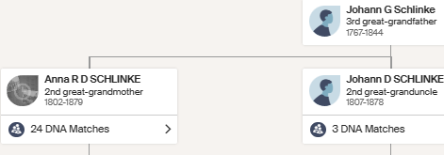

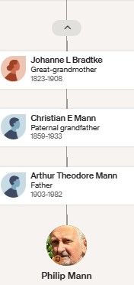

Daniel Schlinke was born on 5 November 1807 at Cichagora, Neutomischel, Posen, Prussia[1] to Johann Gottfried Schlinke, a landowner, and his wife, Rosina Dorothea, nee Janott, a registered midwife.

Cicha Gora[2] is a village 5kms from Neutomischel (Nowy Tomyśl in Polish) in Posen. The region is low-lying and, from its appearance, is probably reclaimed swampland. The Bradtke book[3] suggests that the Prussian king encouraged and assisted Germans to make their homes in such areas and drain the swamps, clear the forests and establish small German settlements where these poor people occupied land at a low rental. Posen only became part of Prussia with the Third Partition of Poland in 1795; however, ethnic Germans had lived in Posen for some centuries as I understand Polish nobles sought skilled German farmers to make their land more productive. During the Napoleonic Wars, Napoleon made Posen part of the Duchy of Warsaw. In 1815, following his defeat, the region returned to Prussian control as the Grand Duchy of Posen. By 1815, Germans made up a predominantly Protestant minority of about one third of the total population of the Posen region, while the majority of the inhabitants identified as Catholic ethnic Poles[4].

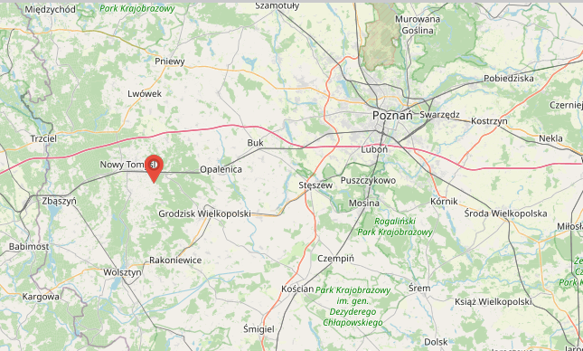

Daniel Schlinke came to South Australia on the Catharina, carrying Old Lutherans, which left Hamburg on 21 September 1838, arriving at Port Adelaide on 25 January 1839. Over 4 months at sea with no stops between Hamburg and Port Adelaide! Incidentally, my 3xgreat grandparents, on my mother’s side, Johann Joseph Gallasch and his wife, Johanne Veronika (nee Wuttke) from Bentschen (Polish name Zbaszyn), 11 miles from Cichagora[5], were also on this sailing ship.

But first some history of South Australia and the reasons Old Lutherans came there. In 1834, the South Australian Colonisation Act was passed in the United Kingdom, leading to the British colonisation of land that is now the state of South Australia[6]. The 1834 Act empowered the King to establish South Australia as a British Province, initially as a commercial and administrative partnership between the British government and the SA Colonization Commission. The Province was to be designed for migrants, not convicts and was to be funded by the sale of land to the wealthy and to investors. This money in turn would partially fund the transport of labourers and other workers to the colony.

The South Australian Company, formed in London in 1835, made a significant contribution to the foundation and settlement of South Australia. It was founded by George Fife Angas and other wealthy British merchants. Its immediate purpose was to encourage the purchase, in advance, of land in the planned colony.

King Frederick Wilhelm III ruled Prussia where most of the people were Protestants (either Calvinist or Lutheran). He wished to unite them in one Church. A group called “old Lutherans” opposed this union and sought to leave Prussia. Pastor Kavel was the Pastor in Klemzig in Brandenburg. Kavel wrote to the King in January 1835, informing him that he would no longer use the worship agenda set down by the King. On Easter Monday 1835, Kavel was removed from the ministry and was prohibited from practising as a pastor[7]. His congregation likewise were prohibited from using the church premises, and participating in any worship services presided over by suspended Pastors.

Pastor Kavel began to look for avenues to lead his congregation in an exodus from Prussia to a place where they could worship in freedom. In early 1836, Kavel travelled to [Hamburg](https://en.wikipedia.org/wiki/Hamburg) to enquire into the possibility of migrating to [Russia](https://en.wikipedia.org/wiki/Russian_Empire) or [the United States](https://en.wikipedia.org/wiki/The_United_States); however, both of these options were not possible.

While in Hamburg, Kavel was informed of the possibility of migrating to Australia. He travelled to London, England, to meet with [George Fife Angas](https://en.wikipedia.org/wiki/George_Fife_Angas), the chairman of the [South Australia Company](https://en.wikipedia.org/wiki/South_Australia_Company), which was searching for emigrants to settle the land acquisitions it had in South Australia. Kavel was received favourably by Angas, who sent his chief clerk, [Charles Flaxman](https://en.wikipedia.org/wiki/Charles_Flaxman), to Prussia to meet with Kavel's group and to prepare them for emigration. Kavel remained in London, ministering to the German community.

Ships were organised to take about 500 of these people to the new English colony of South Australia. Others went to the Ukraine[8], the USA[9] and Canada. About 20% of my DNA matches identified by ancestry.com as 4th cousins or closer are in the USA or Canada. Those Old Lutherans that came to South Australia were predominantly from the borders of Brandenburg, Silesia and Posen, whereas the Old Lutherans who came to Wisconsin in 1839 were mainly from other areas.

On the passenger list of the Catharina[10], Johann Daniel Schlinke is shown as a confectioner from Hamburg. According to Wikipedia[11],

*Confectionery is the art of making confections, which are food items that are rich in sugar and carbohydrates. Exact definitions are difficult. In general, however, confectionery is divided into two broad and somewhat overlapping categories: bakers' confections and sugar confections.*

Was he in Hamburg as part of his Wanderschaft as a journeyman baker/confectioner? According to Lois Zweck[12], this suggestion is perfectly plausible. Lois advised that he would have been expected to do the obligatory journeying although the fact that he is already 31 years old is a little unusual. By about the age of 25, most journeymen would have served their years and be thinking of heading home to do their Meister exam, get married and settle down in their own workshop. But not everyone followed that model. He may have been working for a good master in favourable circumstances and simply decided to stay put.

Alternatively, as Lois pointed out, as one of the passengers on the Catharina, there may be another reason for his being listed as a baker in Hamburg. Unlike the passengers on the Prince George and the Zebra, the Posen people who ended up on the Catharina had sailed to Hamburg without having been promised a ship to take them to Australia. This caused great consternation on their arrival in Hamburg. They had to send to George Fife Angas[13] in London to provide a ship for them, which he eventually did, but in the meantime they had to wait a month or two before they could leave. Since many had little money, those who could find work did while others had to depend on charity.

It should be noted that, in contrast to most of the passengers, there are a number of indications that Daniel Schlinke’s family had money – the number of fireplaces, his mother being a midwife, and his sister being able to afford a divorce.

4 months after his arrival in Port Adelaide, on 24 May 1839, Daniel Schlinke took the oath of allegiance before Governor George Gawler[14]. However, it took 8 years, until 25 March 1847, for the naturalisations of Daniel Schlinke and 305 others “native to Germany” to be confirmed in Ordinance No. 4 enacted by the Governor of South Australia[15]. I have been told that the delay may have been due to Britain itself not having a naturalisation process[16]

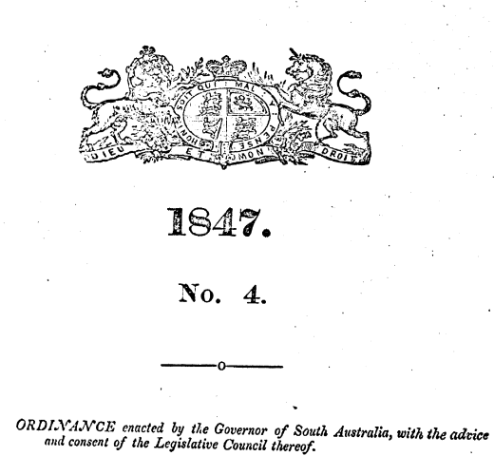

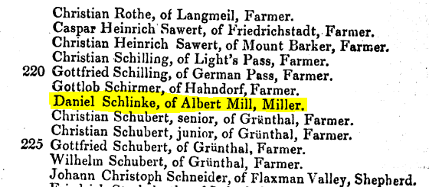

In the Ordinance, Daniel Schlinke is shown as being from Albert Mill, which was South Australia’s first flour mill, just outside Nairne in the Adelaide Hills[17].

When and how did Daniel Schlinke move from being a baker to being a miller? Had he trained in both trades before moving to South Australia?

Once they reached South Australia, my ancestors’ (and many other Germans’) moves were generally made as they sought land to farm. Below is a graphical generalisation of the moves my family made over time. In general, Mum’s side moved to Hahndorf and then Murray Bridge and Dad’s side went via the Barossa Valley to Point Pass, then Sherlock and Murray Bridge.

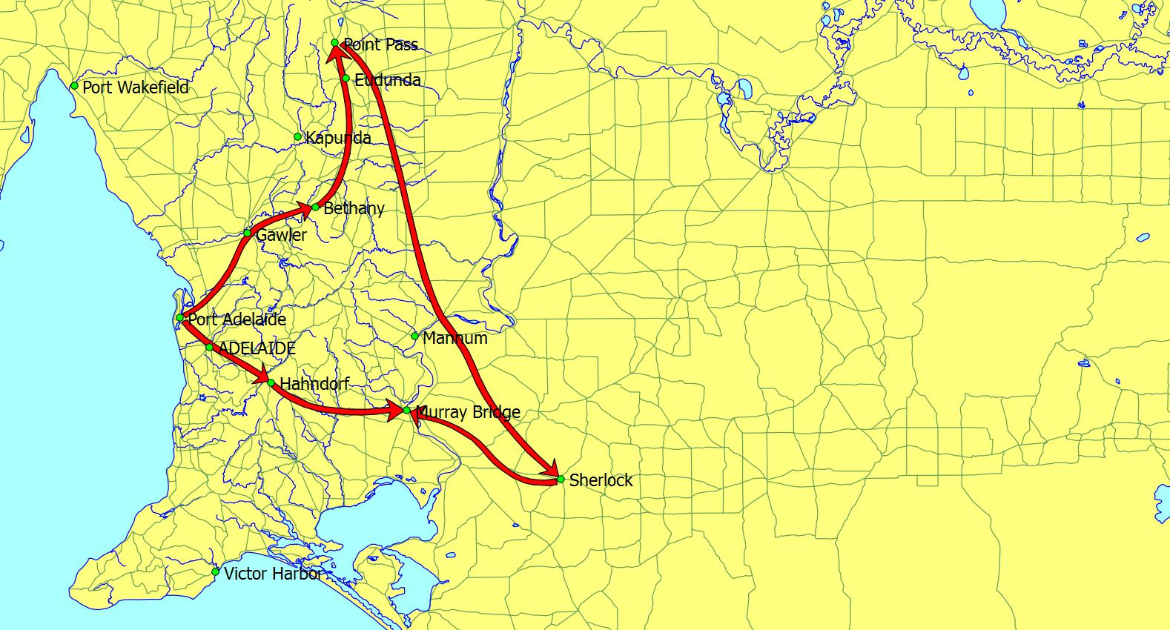

Figure 1 The movement of my ancestors in South Australia.

Daniel Schlinke’s first wife, Bertha Mathilde Teusler, was born on 29 November 1822 and came to South Australia with Pastor Kavel on the Prince George in 1838, with her mother, Johanna Maria Teusler (nee Koehler) and her second husband, Johann Friedrich August Fiedler and four children from his first marriage[18]. Her mother died on 5 December 1838, 17 days after arrival at Port Adelaide, leaving Bertha at 16 to look after her stepfather and 4 step-siblings aged 5½ to 16. Meanwhile, Bertha had 2 suitors, the missionary Clamor Schürmann and the miller Daniel Schlinke, 15 years her senior. The details are covered by Schürmann’s extensive diaries, which are likely to be published with other of his correspondence in 2024. The diaries indicate the involvement of Pastor Kavel. It is possible that Bertha’s stepfather, August Fiedler, thought that the entrepreneur Schlinke was likely to be more able to assist his business interests than the missionary Schürmann.

My American 4th cousin, Stephen (Woody) LaBounty[19] also quotes from an earlier translation of the Schürmann diaries. He reports that Bertha Teusler and Daniel Schlinke were married on 8 July 1840 by Pastor Kavel at Klemzig, South Australia, named after his Church’s location in Brandenburg, either in the church or at the Fiedler home. They had seven children before her death at age 30 on 10 December 1852.

On 18 May 1842, Daniel Schlincke purchased a land grant of 135 acres of Sections 1936 and 1937 of the Wiltshire Special Survey at Bethany for ₤135[20]. Note the spelling of his surname[21] (with a “c” before the “k”).

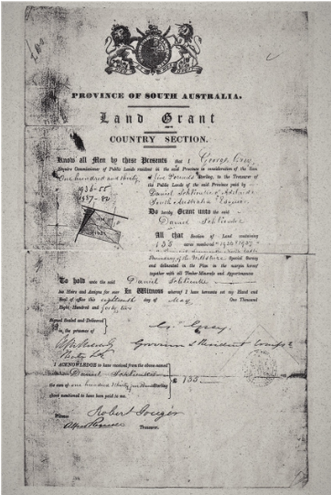

A report in the Sydney Morning Herald of 29 September 1843[22] showed that Daniel Schlinke operated a bakery business from Grenfell Street, Adelaide, and reported the building of the mill at Bethany. It is unusual for South Australian activities to be reported in Sydney newspapers so the building of the mill must have been seen as very significant.

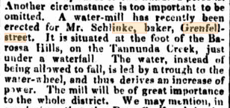

Anna Schrapel provides a description of the building[23]. The builder, Mr T Y Wakeham of Grenfell Street, Adelaide constructed from local stone a two-storey building with several windows and doors. The roof consisted of shingles. A wooden channel/aqueduct conveyed water from the waterfall to the waterwheel which was mounted on high trestles built of native timber. The wheel is said to have measured 15 feet in diameter.

A pen drawing[24] of the mill shows what it would have looked like before it was damaged.

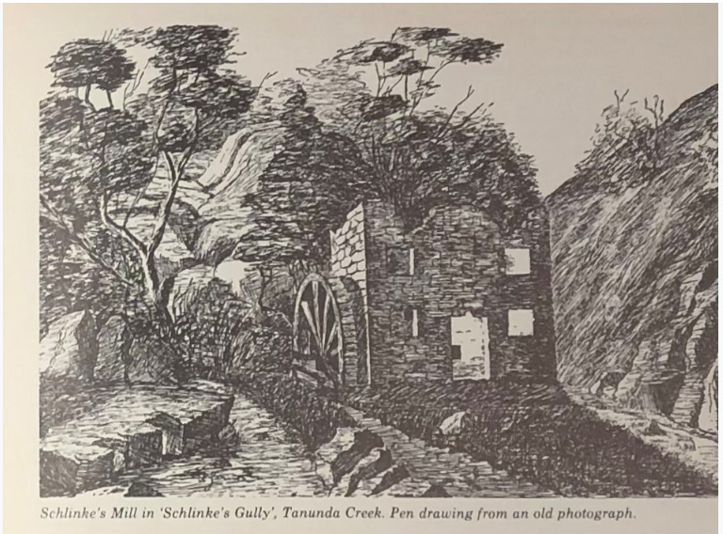Grain and milling were very important in the early years of the colony of South Australia. Schrapel[25] reports that local farmers from all over the Valley brought wheat for Daniel Schlinke to grind. By 1844, 18 months after the arrival of the pioneers of Bethany, they had 495 acres under cultivation, of which 381 ½ acres were wheat[26]. By 1847, the mill was grinding 200 lbs of flour[27].

Drays pulled by bullock teams carted the local wheat along the sloping banks of the creek up to the mill, causing huge ruts. Sometimes they did not make it.

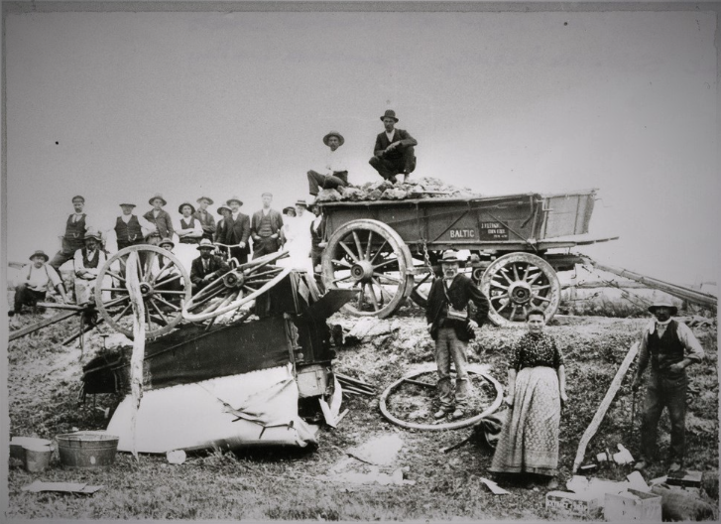

Figure Broken down wagon on its way to the mill. B45896 State Library of South Australia.

Heuzenroeder[28] reports that some Lutheran settlers brought their hand mills while others used the method of grinding grain between two grindstones. To satisfy the demand for staple European food for both the English and German population, commercial mills with large millstones soon appeared in the colony. Within 6 years, at least 6 mills, mainly windmills and watermills, were in operation around Adelaide. Heuzenroeder identifies that Schlinke’s watermill at Bethany sometimes suffered from the sluggish water flow but then it lost its aqueduct in a flash flood.

An article on AdelaideAZ notes that steam-powered flour mills were an early machine technology operating in Adelaide in response to the success of the 20 acres of wheat planted on the Adelaide plains in 1838[29]. Flour milling became the first secondary industry of the colony.

Schrapel reports that between 1848 and 1850, water supply went from inadequate to destructive, and a flood destroyed the aqueduct. The first two storeyed water powered mill in South Australia, at Schlinke’s Gully, only survived 7 years.

A drawing of Daniel Schlinke’s Bethany mill, after being damaged, is shown below[30].

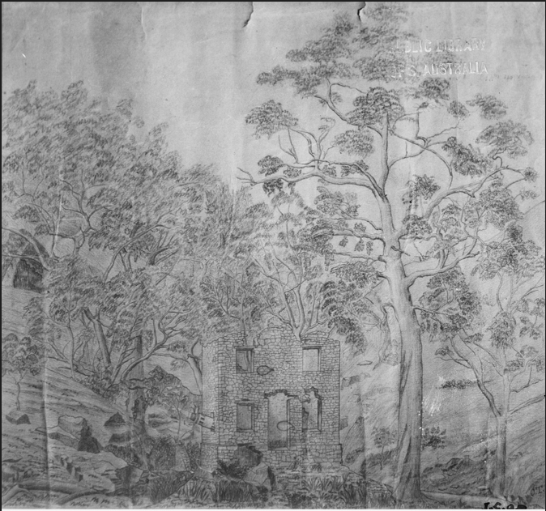

Figure 'Sketch by J.G.O. Tepper / (Mill supposed to be at Mr. Schlinke's mill, (baker) at Tanunda Creek and the second water mill in S.A.. Details supplied by Mr. T.P. Lippinus 21/9/1976). Watermill [B 4159]. State Library of South Australia.

However, the Schlinke’s Creek mill was destroyed by floods in the 1920s and little remains of this mill[31].­­

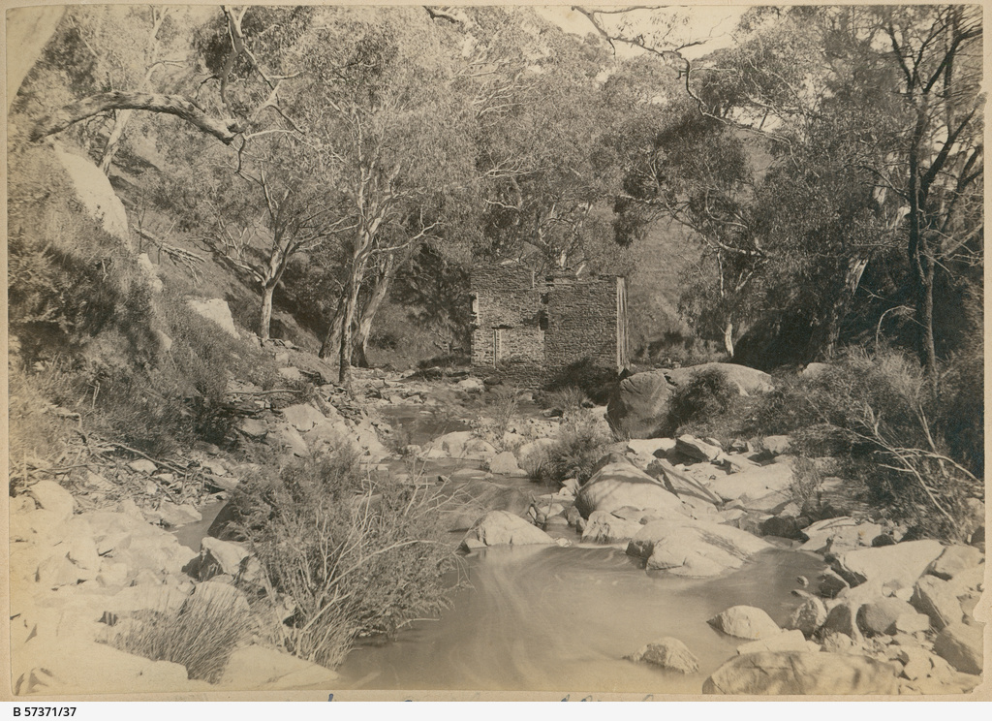

Figure Ruins of Schlinke’s Gully mill (Image courtesy of SLSA B57371/37).

“A Historical Walk of Bethany”[32] details that 3 cottages were built on the property. These included the first residences in South Australia of Daniel Schlinke’s sister, Rosina Bradtke (nee Kucke, nee Schlinke) and her husband, Wilhelm Bradtke, and their family, and her daughter, my great grandmother Louise and her husband, my great grandfather, Johann Christian Mann. This brochure also shows that the mill only functioned for a few years until it was damaged by flood. The property on which the mill was built was purchased from Daniel Schlinke in 1858 by the Schrapels. Before selling his original title to the Schrapels, Daniel Schlinke bought a further 55 acres towards the foothills of Bethany for £5 per acre[33]. Schrapels Family Vineyards (Bethany Wines), which is still owned by that family, operate from the original site.

A more reliable 6 horse-power steam flour mill was built by William Bollensdorf in Tanunda by 1850/51 on land transferred to Daniel Schlinke from Pastor Kavel. It is believed to have commenced operating in 1848[34]. A photo of the mill and a map showing its location on the corner of Murray Street and Jane Place (#6 on the map) are shown below.

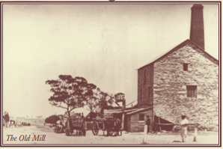

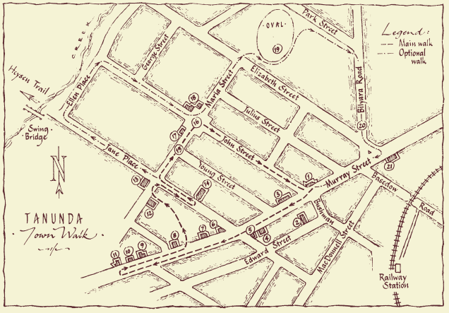



Daniel Schlinke may have ceased operating the mill from about 1863, given the advertisement[35] in the South Australian Register to lease or sell the mill.

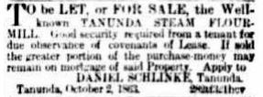

Daniel Schlinke is listed in the “Church Book of the Lutheran, Apostolic Congregation of Langmeil, Upper-Langmeil, Light’s Pass, Bethany, and surroundings, 1849” as having 9 other members of the family living with him in Tanunda[36]. I have examined the Langmeil Church registers[37] and he is described as a mühlenbesitzner (mill owner) in 1850 and an eigenthümer (property owner) from 1852 onwards.

He was also trustee of the Church and overseer of the Langmeil Church cemetery.

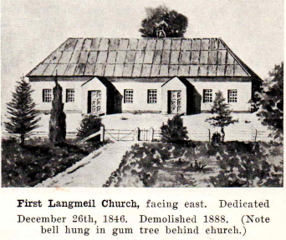

Figure Source: Langmeil 1843 - 1968.

On 22 May 1856, Daniel Schlincke purchased Section 743, County of Light, Hundred of Moorooroo (26 acres), about 11 miles north-east of Krondorf, for £58.

According to the 1990 Tanunda Heritage Survey[38], 30 Murray Street, Tanunda (Valley Ford offices) was Tanunda's first hotel building and was probably built by Daniel Schlinke by 1865. Initially it was Daniel Schlinke’s Tanunda home.

After his first wife, Bertha’s death, Daniel Schlinke married Ottilie Louise Maria Laura von Hoffmann on 9 March 1854 and they had three children. As reported by Stephen LaBounty[39], according to family stories, Daniel’s relationship with Ottilie became contentious, with fights over money and her spending. These have been confirmed by classified ads Daniel took out in a number of South Australian newspapers warning the public that he would not honour debts his wife might incur.

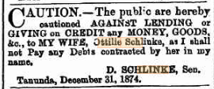

From her grave[40], we know that Ottilie died on 2 July 1912 (aged 93) in San Francisco, California, and is buried in Cypress Lawn Memorial Park, Colma, San Mateo County, California. Her will[41] left $10 to her son, Otto, address unknown, with the rest shared by her daughters, Louise Frisch of Port Pirie, South Australia (or her 4 children), and Marie Nugent of San Francisco, California.

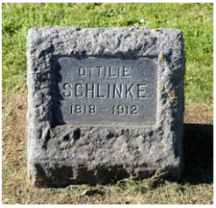

Colma is about 16 miles south[42] of Sausalito, where two of her stepsons lived.

These two step-sons, Daniel Schlinke’s sons from his first marriage to Bertha Teusler, Johann Emil and Daniel Joseph, also caused some financial challenges and left Australia. Their exploits are eloquently and adequately covered on <http://woodylabounty.com/slinkey-story.php>.



According to Anna Schrapel, Johann Daniel Schlinke, whilst residing in Tanunda, was a member of the Masonic Lodge in his later years.

Johann Daniel Schlinke died at Tanunda on 13 August 1878 and is buried beside his wife Bertha (nee Teusler) in the Langmeil Lutheran Cemetery at Tanunda[43].

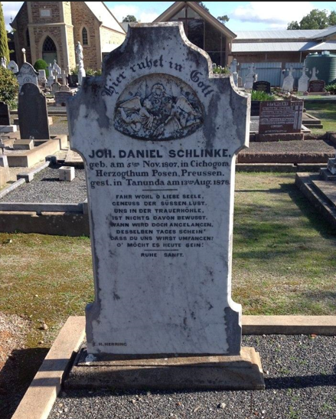

After Daniel Schlinke’s death, the Tanunda Mill was part of his estate and was auctioned[44].

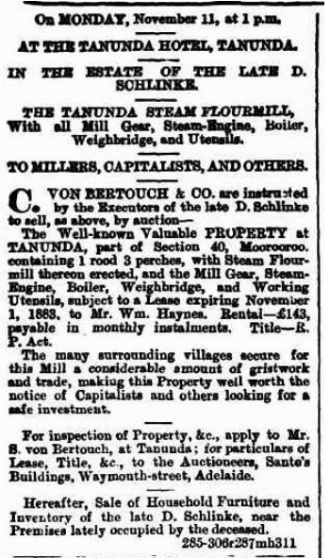­

The mill sold for ₤802 to its present tenant, Mr W Haynes[45].

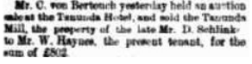

Daniel Schlinke’s will contained the following specific bequest[46].

Johann Emil Schlinke was Daniel Schlinke’s second son by Bertha Teusler. He was born on 3 November 1842 in Adelaide. His mother died when he was 10 and his father remarried two years later. He attended St Peter’s College and played cricket and football (for the Adelaide Football Club) in the early 1860s, and was secretary of the St Peter’s Old Scholars’ Association and played pianoforte as part of a duet.

He was made insolvent in the week ending 16 March 1866[47]. He is reported to have left Australia, under the name Saunders on the barque Anna bound for San Francisco, after embezzling under £150 from his employer, Francis Clark and Sons.

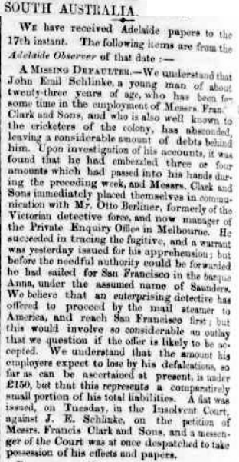

Debts are not all he left behind. On 15 September 1866, he was named as the father of Annie Sophia Schlinke born in Adelaide to Kate Maria Salcombe[48].

On arrival in San Francisco, he was involved in a number of businesses, several of which burnt down. Their losses appear to have been almost completely covered by insurance. In 1873, John E Slinkey was naturalised as a US citizen in California. In 1876, he purchased a large hotel in Sausalito overlooking the bay.

On 1 May 1882, he opened the El Monte Hotel[49].

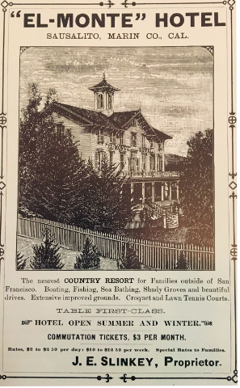

His story is incredible and indicates a full life and may be best left to another time or to Stephen LaBounty who gathered all the information. John E Slinkey died on 4 March 1920 in San Francisco.

His brother, Daniel Joseph Schlinke was born in August 1841 in Adelaide and was the oldest of Daniel and Bertha’s children. He also appeared in the courts in South Australia before appearing in California working in one of his brother’s establishments as a bartender. Like his brother, it was a colourful life in California, including as a poundkeeper, ended when he suicided on 16 August 1900 in Sausalito.

Johann Daniel Schlinke donated land at 28 Murray Street for Tanunda’s first Institute. I am informed the bluestone came from the quarry on the property he had first settled on.

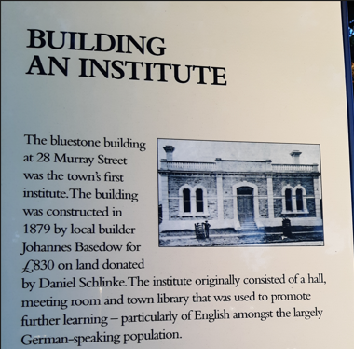

My sincere thanks to:

* Anna Schrapel, for discussion and her knowledge of the Bethany property and the Barossa;
* Stephen W LaBounty, for his details on Daniel Schlinke’s sons in the USA;
* Lorraine Lovell, for discussions and information on John Gray’s detailed Schlinke family research; and
* Lois Zweck, for her advice on the early German settlements in South Australia.

without whose information and assistance, this would have been a much poorer presentation.

Philip Mann

20 March 2024.

# Sources

*A Dwelling-Place at Bethany*, HFW Proeve, 1983.

*Bethany Profiles*, compiled by PA Scherer, 1993.

*Schlinke-Teusler Family in South Australia, Stephen W LaBounty, Schlinke_Teusler-Report_2020_02_07*, February 2020.

[*http://woodylabounty.com/slinkey-story.php*](http://woodylabounty.com/slinkey-story.php).

[*https://www.sausalitohistoricalsociety.com*](https://www.sausalitohistoricalsociety.com/).

*Bradtke Family History*¸ The Bradtke Family Reunion Committee, 2000.

*From Shuttle to Plough: The Gallasch Family: Early Pioneers of South Australia*, Third Edition, February 2003, compiled and printed by Eric and Ruth Fiebig.

*The Barossa Survey: Final Report of A Research Project by the School of Architecture, S.A. Institute of Technology, and the Department of History, Adelaide College of Advanced Education, for the Australian Heritage Commission*. Published 1977. [*https://data.environment.sa.gov.au/Content/heritage-surveys/3-Barossa-Survey-Vol-3-1977.pdf*](https://data.environment.sa.gov.au/Content/heritage-surveys/3-Barossa-Survey-Vol-3-1977.pdf).

*The Barossa Council Heritage Review Volume I 2001*, prepared for The Barossa Council and Department for Environment, Heritage and Aboriginal Affairs by McDougall & Vines. [*https://data.environment.sa.gov.au/Content/heritage-surveys/2-Barossa-Council-Heritage-Review-Vol-1-2001.pdf.*](http://www.meyersgaz.org/)

*A Food Culture Transplanted: Origins and Developments of the Food of Early German Immigrants to the Barossa Region, South Australia (1839 – 1939)*, Angela Heuzenroeder, Thesis presented as requirement for the degree of Doctor of Philosophy in the School of Humanities, University of Adelaide, 2006.Australia, South Australia, Will and Probate Records, database, FamilySearch.

*Langmeil Congregation 1843 – 1968*, printed by the Lutheran Press.

<http://classic.austlii.edu.au>

[http://classic.austlii.edu.au](http://classic.austlii.edu.au/)

[www.meyersgaz.org](http://www.meyersgaz.org/).

[http://www.theshipslist.com](http://www.theshipslist.com/ships/australia/catharina1839.shtml).

[https://en.wikipedia.org](https://en.wikipedia.org/).

[https://trove.nla.gov.au](https://trove.nla.gov.au/).

<http://adb.anu.edu.au/biography/angas-george-fife-1707>.

[https://guides.slsa.sa.gov.a](https://guides.slsa.sa.gov.a/)u.

[https://www.ancestry.com.](https://billiongraves.com/)

[https://www. familysearch.org.](https://billiongraves.com/)

<https://billiongraves.com/>.

[https://www.findagrave.com](https://www.findagrave.com/).

[https://www.walkingsa.org.au](https://www.walkingsa.org.au/).

[https://www.barossa.com](https://www.barossa.com/).

[http://www.collections.slsa.sa.gov.au](https://collections.slsa.sa.gov.au/).

[https://adelaideaz.com](https://adelaideaz.com/).

GoogleMaps.

1. According to the Langmeil (Tanunda) church register, as reported on Page 1 of *Bethany Profiles*, compiled by PA Scherer, 1993.
2. There are a number of variant spellings.
3. *Bradtke Family History¸* The Bradtke Family Reunion Committee, 2000.
4. <https://en.wikipedia.org/wiki/Germanisation_of_the_Province_of_Posen>, accessed 3 February 2024.
5. www.meyersgaz.org.
6. Much of this section is from <https://guides.slsa.sa.gov.au/c.php?g=410270&p=2794886>, accessed 20 February 2024.
7. Much of this section is from <https://en.wikipedia.org/wiki/August_Kavel>, accessed 20 February 2024.
8. Through the results of my Ancestry DNA test, I have had contact with 4th cousins in North America, whose ancestors came from Volhynia in the Ukraine; a fascinating story of the movement of some of these families from Germany to Ukraine to Siberia and then to Germany and North America is told in the book *The Women of Janowka: A Volhynian Family History* by Helmut Exner, 2012. I have not yet worked out how we connect.
9. *From Shuttle to Plough: The Gallasch Family: Early Pioneers of South Australia*, page 10.
10. http://www.theshipslist.com/ships/australia/catharina1839.shtml.
11. <https://en.wikipedia.org/wiki/Confectionery>, accessed 7 December 2023.
12. Lois Zweck, pers. comm., 9 December 2023.
13. http://adb.anu.edu.au/biography/angas-george-fife-1707.
14. Much of this section is sourced from *Bethany Profiles*, compiled by PA Scherer, 1993.
15. <http://classic.austlii.edu.au/au/legis/sa/num_act/na4o10a11v1847274/>, accessed 15 October 2020.
16. Pers. comm. Lois Zweck.
17. <https://collections.slsa.sa.gov.au/resource/B+7801>, accessed 7 December 2023.
18. Scherer.
19. Stephen W LaBounty, *Schlinke-Teusler Family in South Australia*,Schlinke_Teusler-Report_2020_02_07, February 2020.
20. *Schlinke’s Gully History*, compiled by Anna Schrapel (COVID Project) April 2020.
21. Source: Anna Schrapel.
22. <https://trove.nla.gov.au/newspaper/article/12427103?searchTerm=Schlinke%20%22Grenfell%20Street%22>, accessed 9 December 2023.
23. *Schlinke’s Gully History*, compiled by Anna Schrapel (COVID Project) April 2020.
24. Proeve, page 25.
25. *Schlinke’s Gully History*, compiled by Anna Schrapel (COVID Project) April 2020.
26. *The Barossa – A Vision Realised. The 19th Century Story,* Don Ross, page 49, from Allen’s Almanac 1844.
27. Schrapel.
28. Angela Heuzenroeder, *A Food Culture Transplanted: Origins and Developments of the Food of Early German Immigrants to the Barossa Region, South Australia (1839 – 1939)*, Thesis presented as requirement for the degree of Doctor of Philosophy in the School of Humanities, University of Adelaide, 2006.
29. <https://adelaideaz.com/articles/god-early-wheat-crops-bring-a-boom-in-flour-mills-machinery-to-the-fledgling-colony>, accessed 4 January 2024.
30. HFW Proeve, *A Dwelling-Place at Bethany*, 1983, page 25.
31. *The Barossa Council Heritage Review Volume I 2001*, prepared for The Barossa Council and Department for Environment, Heritage and Aboriginal Affairs by McDougall & Vines. <https://data.environment.sa.gov.au/Content/heritage-surveys/2-Barossa-Council-Heritage-Review-Vol-1-2001.pdf>, accessed 2 October 2023.
32. “A Historical Walk of Bethany”, <https://www.walkingsa.org.au/wp-content/uploads/2016/09/Bethany20Town20Walk.pdf>, accessed 6 December 2023.
33. Schrapel.
34. “A Town Walk of Tanunda”, <https://www.barossa.com/file/zkz7ppvh9/Tanunda%20Heritage%20Town%20Walk.pdf>, accessed 6 December 2023.
35. South Australian Register (Adelaide, SA : 1839 - 1900), Friday 27 November 1863, page 1, <https://trove.nla.gov.au/newspaper/rendition/nla.news-article50160798.3.pdf?followup=690d7c03d94c5d690ce60d50681a7c46>, accessed 15 February 2024.
36. *Langmeil Congregation1843 – 1968*, printed by the Lutheran Press.
37. In a visit to the Lutheran Archives 30 January 2024.
38. <https://data.environment.sa.gov.au/content/heritage-surveys/lower-north-eight-towns-heritage-survey-tanunda-1990.pdf>, accessed 31 December 2023.
39. Stephen W LaBounty, *Schlinke-Teusler Family in South Australia*,Schlinke_Teusler-Report_2020_02_07, February 2020.
40. <https://www.findagrave.com/memorial/202133453/ottilie-schlinke>, accessed 6 February 2024.
41. ### California, U.S., Wills and Probate Records, 1850-1953, accessed via Ancestry.com, 15 February 2024.

   
42. Google Maps, accessed 6 February 2024.
43. The photo below is from BillionGraves.
44. 1878 <https://trove.nla.gov.au/newspaper/article/160114377>, accessed 6 December 2023.
45. South Australian Register (Adelaide, SA : 1839 - 1900), Monday 18 November 1878, page 1, <https://trove.nla.gov.au/newspaper/article/42990125>, accessed 6 December 2023.
46. "Australia, South Australia, Will and Probate Records," database, FamilySearch (https://familysearch.org/ark:/61903/3:1:3Q9M-CSN1-G5K?cc=3007557 : 26 September 2019), > image 1 of 1; Filae, Genalogie.com, Paris. <https://www.familysearch.org/ark:/61903/3:1:3Q9M-CSN1-G5K?cc=3007557&personaUrl=%2Fark%3A%2F61903%2F1%3A1%3AQY3Y-59MM>, accessed 9 December 2023.
47. *Commercial* Intelligence, South Australian Register, Friday 16 March 1866, page 2, <http://nla.gov.au/nla.news-article41032816>, accessed 7 October 2023.
48. *Births Registration*, Annie Sophia Schlinke, Genealogy SA, accessed 6 February 2024.
49. Colonel Slinkey and the El Monte Hotel, 5 October, 2016, Jack Tracy, Sausalito Historical Society, <https://www.sausalitohistoricalsociety.com/2016-columns/2016/10/5/colonel-slinkey-and-the-el-monte-hotel>, accessed 18 February 2024.