Daniel Schlinke: Entrepreneur

Presented to Friends of Lutheran Archives 26 June 2025.
Johann Daniel Schlinke was born on 5 November 1807 at Cicha Góra, Neutomischel, Posen, Prussia to Johann Gottfried Schlinke, a landowner, and his wife, Rosina Dorothea, nee Janott, a registered midwife.

Introduction
In this paper, I cover the background and life of this prominent early South Australian who lived over half of his entire life in South Australia. In particular, I will discuss:
- the establishment and development of his birthplace, Cicha Góra;
- the move of the old Lutherans to South Australia;
- his naturalisation;
- the life story of his first wife, Bertha Teusler;
- the mills;
- his second wife, Ottilie Louise Maria Laura von Hoffmann; and
- his estate and legacy.

Cicha Góra
Cicha Góra is a village 5kms from Neutomischel (Nowy Tomyśl in Polish) in Posen. Its location is shown in the extract from Google Maps.
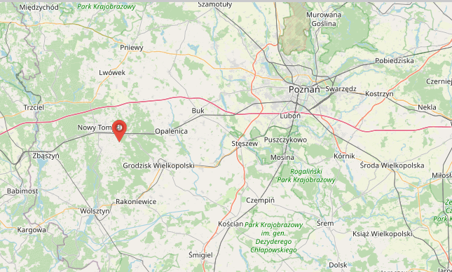 The history of Cicha Góra, which follows, has been extracted from the history page on the village’s website.
On 11 November 1757, Cicha Góra began as a location for an Olęder (German Haulander) settlement on lands belonging to the Opaliński family from Opalenica. This settlement was located near a hill and a yew forest, after which the original name was derived. Cicha Góra was one of many Olęder settlements established in the vicinity of Nowy Tomyśl. Olęder settlers had been settling in that area since the 18th century. They were not Dutch, but German peasants. However, they settled according to Dutch law, which is why they were called Dutch, and later mainly Olęder. Cicha Góra was created as a result of clearing the forest and improving the land.
The newcomers were settled on favourable terms, most often on difficult, marshy land or in the middle of large forest complexes, i.e. in areas that no one had previously attempted to develop. The main reason for the settlers' arrival in Poland was the difficult living conditions and religious persecution in their own homeland (Daniel Schlinke’s mother was born in Baden-Württemberg). The people arriving were mostly Protestant. The landowners who settled German colonists wished to increase the area of ​​cultivation and the profitability of their estates by collecting rents from the settlers.
Usually, the settlers themselves prepared and measured the land designated for them to farm. They were free people; therefore, they had the right to their own self-government, a village head, and lay assessors. By clearing forests, digging ditches, draining marshes and creating arable fields, they began to change the original landscape of the local area on an unprecedented scale.
The Olęder colonization, through the organizational and economic system introduced in the villages, had a positive influence on the development of the areas located within the Nowotomysz Plain, even though the local soils were of low quality. Taking advantage of the specific soil and climate conditions, they cultivated hops and wicker, among other things. In addition, they were engaged in animal breeding, beekeeping, fishing, crafts, trade and ran inns, which may have been what Daniel Schlinke’s father did.
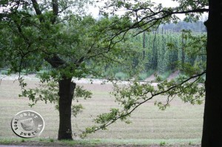
Figure 1 View over the hop fields of Cicha Góra, http://hauland.de/aus-der-kirchenchronik-von-hammer-boruy-einweihung-der-kirche-1777-und-einpfarrung-der-gemeinde-chicagora-1817/, accessed 8 June 2025.
The almost two-hundred-year history of German colonists in Cicha Góra and other settlements ended at the end of the Nazi occupation in 1945. All descendants of the Olęder settlers left these areas.

Posen
Posen only became part of Prussia with the Third Partition of Poland in 1795; however, ethnic Germans had lived in Posen for some centuries. During the Napoleonic Wars, Napoleon made Posen part of the Duchy of Warsaw. In 1815, following his defeat, the region returned to Prussian control as the Grand Duchy of Posen. By 1815, Germans made up a predominantly Protestant minority of about one third of the total population of the Posen region, while the majority of the inhabitants identified as Catholic ethnic Poles.

Kirchplatz Borui
Johann Daniel Schlinke was baptised on 6 November 1807 at the Evangelical parish church of St. Adalbert, Kirchplatz Borui (now Catholic parish of St. Wojciech, Boruja Kościelna, Nowy Tomyśl).
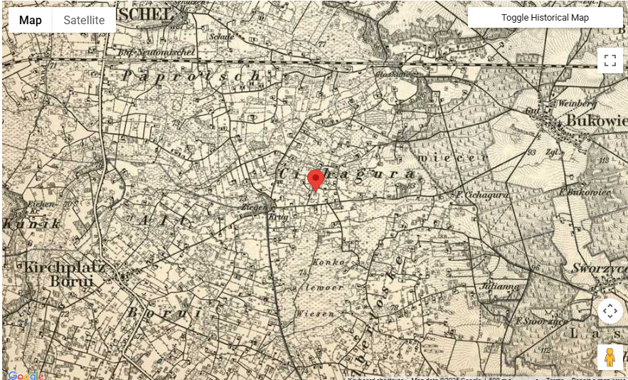
Figure 2 https://www.meyersgaz.org/place/10297010, accessed 13 May 2025.
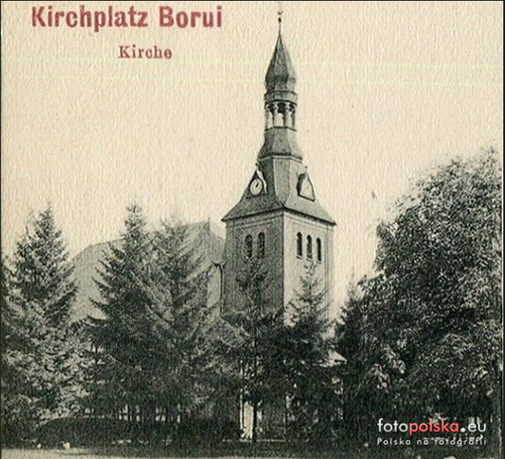
Figure 3 Church of St. Wojciech in Boruja Kościelna in 1907. https://fotopolska.eu/nowe_zdjecia/Polska.html?galeria_zdjec=&m=12307&wykonane_do_rok=1995&archiwalne=1&f=1314078-foto, accessed 8 June 2025.

Old Lutherans
Daniel Schlinke is listed as coming to South Australia on the Catharina, carrying Old Lutherans, which left Hamburg on 21 September 1838, arriving at Port Adelaide on 25 January 1839. He was definitely here in 1839 but the passenger list also shows Bertha Teusler as his wife and 2 children; this is not correct as she was only 16 and being courted by both Daniel Schlinke and Clamor Schürmann in late 1839, but more of that later.
Over 4 months at sea with no stops between Hamburg and Port Adelaide! I find less than a day in a plane to Europe far too long!
But first some history of South Australia and the reasons Old Lutherans came here. In 1834, the South Australian Colonisation Act was passed in the United Kingdom, leading to the British colonisation of land that is now the state of South Australia. The 1834 Act empowered the King to establish South Australia as a British Province, initially as a commercial and administrative partnership between the British government and the SA Colonization Commission. The Province was to be designed for migrants, not convicts and was to be funded by the sale of land to the wealthy and to investors. This money in turn would partially fund the transport of labourers and other workers to the colony.
The South Australian Company, formed in London in 1835, made a significant contribution to the foundation and settlement of South Australia. It was founded by George Fife Angas and other wealthy British merchants. Its immediate purpose was to encourage the purchase, in advance, of land in the planned colony.
King Frederick Wilhelm III ruled Prussia where most of the people were Protestants (either Calvinist or Lutheran). He wished to unite them in one Church. A group called “old Lutherans” opposed this union and sought to leave Prussia. Pastor Kavel was the Pastor in Klemzig in the province of Brandenburg. Kavel wrote to the King in January 1835, informing him that he would no longer use the worship agenda set down by the King. On Easter Monday 1835, Kavel was removed from the ministry and was prohibited from practising as a pastor. His congregation likewise were prohibited from using the church premises, and participating in any worship services presided over by suspended Pastors.
Pastor Kavel began to look for avenues to lead his congregation in an exodus from Prussia to a place where they could worship in freedom. In early 1836, Kavel travelled to Hamburg to enquire into the possibility of migrating to Russia or the United States; however, both of these options were not possible.
While in Hamburg, Kavel was informed of the possibility of migrating to Australia. He travelled to London, England, to meet with George Fife Angas, the chairman of the South Australia Company, which was searching for emigrants to settle the land acquisitions it had in South Australia. Kavel was received favourably by Angas, who sent his chief clerk, Charles Flaxman, to Prussia to meet with Kavel's group and to prepare them for emigration. Kavel remained in London, ministering to the German community.
Ships were organised to take about 500 of these people to the new English colony of South Australia. Those Old Lutherans that came to South Australia were predominantly from the borders of Brandenburg, Silesia and Posen, whereas the Old Lutherans who went to Wisconsin in 1839 were from diverse areas including Pomerania, Silesia, Saxony and the Mark.
On the passenger list of the Catharina, Johann Daniel Schlinke is shown as a confectioner from Hamburg. According to Wikipedia,
Confectionery is the art of making confections, which are food items that are rich in sugar and carbohydrates. Exact definitions are difficult. In general, however, confectionery is divided into two broad and somewhat overlapping categories: bakers' confections and sugar confections.
Was he in Hamburg as part of his Wanderschaft as a journeyman baker/confectioner? According to Lois Zweck, this suggestion is perfectly plausible. Lois advised that he would have been expected to do the obligatory journeying although the fact that he is already 31 years old is a little unusual. By about the age of 25, most journeymen would have served their years and be thinking of heading home to do their Meister exam, get married and settle down in their own workshop. But not everyone followed that model. He may have been working for a good master in favourable circumstances and simply decided to stay put. Or he may have been on one of the first steps on his entrepreneurial journey.
Alternatively, as Lois pointed out, as one of the passengers on the Catharina, there may be another reason for his being listed as a baker in Hamburg. Unlike the passengers on the Prince George and the Zebra, the Posen people who ended up on the Catharina had travelled to Hamburg without having been promised a ship to take them to Australia. This caused great consternation on their arrival in Hamburg. They had to send to George Fife Angas in London to provide a ship for them, which he eventually did, but in the meantime they had to wait a month or two before they could leave. Since many had little money, those who could find work did while others had to depend on charity.
It should be noted that, in contrast to most of the passengers, there are a number of indications that Daniel Schlinke’s family had money – the number of fireplaces, his mother being a registered and qualified midwife, his sister being able to afford a divorce, and he being able to build a mill within 3 years of arriving in South Australia.

The Oath of Allegiance
4 months after his arrival in Port Adelaide, on 24 May 1839, Daniel Schlinke took the oath of allegiance before Governor George Gawler.
On 20 August 1841, it was reported in an Adelaide newspaper that "”An Act for the Naturalization of certain persons, natives of Germany," has, … been disallowed by the Home Government”.
It took 8 years, until 25 March 1847, for the naturalisations of Daniel Schlinke and 304 others “native to Germany” to be confirmed in Ordinance No. 4 enacted by the Governor of South Australia.
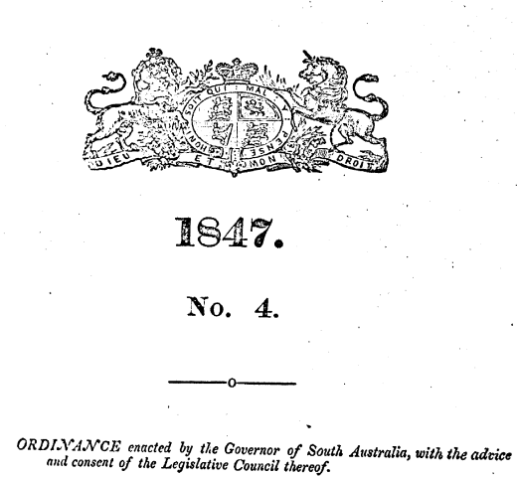
The Ordinance listed 305 Germans. A small part of the list is shown below.
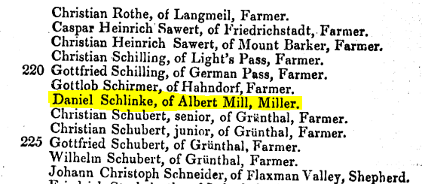
In the Ordinance, Daniel Schlinke is shown as being from Albert Mill, which was an early South Australian flour mill, just outside Nairne in the Adelaide Hills. According to A Miller’s Tale: The Memoirs of John Dunn of Mount Barker, the mill shown below which Dunn & Co bought in July 1864 carried its former name as well as that of its owners.
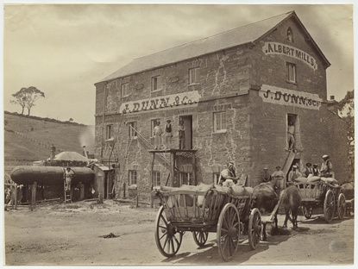
Figure 4 J.Dunn & Co. flour mill at Nairne. South Australia's first flour mill was built just outside Nairne in 1841. Steam driven mill was added in 1857 and operated by John Dunn from 1864. The Mill was named Albert Mill after the husband of Queen Victoria, accessed 3 June 2025. State Library, B7801.
Whether Daniel Schlinke was temporarily there learning about steam-powered mills or not we do not know. We do know he was living in Bethany and would soon be operating a mill in Tanunda.

Naturalisation
In a circular from Downing-Street in London dated 25 September 1847, it was reported that an Act was passed in the British Parliament “For the Naturalization of Aliens”. Laws had been passed in various colonies to impart the privileges of natural-born British subjects to aliens. There had been concern on whether these laws were effective, the variation between colonies and whether they complied with existing British law. This Act was to resolve these concerns.
On 3 May 1848, Daniel Schlinke received his Naturalization Certificate. A newspaper report of the naturalisations of Daniel Schlinke and 233 other Germans in the Supreme Court by Charles Cooper from a British perspective makes amusing reading. Judge Cooper “went through the somewhat arduous task of guarding against discrepancies between the certificates to be given, and the correct Christian and surnames of the recipients: an object not readily accomplished amidst the multitude and almost ridiculous diversity of names with which it is the wont of some German parents to encumber their numerous offspring”. To quote further, “A shoemaker of modest appearance, and pretensions, laid claim to three Christian names only, viz.:—Johann, Christian, and Samuel, every one of which names, as he alleged, he had caused to be sent in as that of an applicant for naturalization, though singly and at different times, consequently appearing in three different places of the Act together with his surname; he failed, however, to convince his Honor of his identity in law with any one of the said three naturalised lieges for whom (although in nubibus) the Act had provided”. Of the 305 in the Act, 9 did not receive certificates by reason of deficiencies in the number of letters or variations in the spelling of their Christian names, very satisfactory proofs of identity not being sufficient. Pastors Fritsche and Kavel “assisted much to identify the parties who for the most part were sworn in sets of 12 or 16 to 25, the oath being read by the Clerk of the Court in English, and stated in German through Dr Hubbe”. “Very many Germans were much disappointed in finding their names omitted in the Act, and some of them even professionally employed Mr Poulden to tender their affidavits to the fact of their having been duly sent in as applicants.”
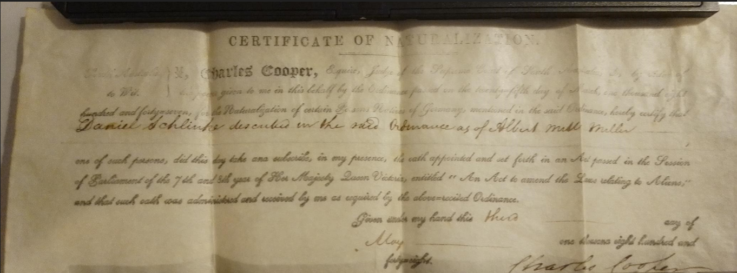
Figure 5 Photo by Mark Cody.
I was contacted in February 2025 by Mark Cody, who I had not previously met, who explained that he had found one South Australian certificate in a collection kept by his late father and had googled the name “Daniel Schlinke” and found my blog. After contacting a number of likely repositories, it was decided that, given its proximity to where Daniel worked and lived, the Barossa Museum in Tanunda was the most suitable and would provide maximum public exposure.
On 17 May 2025, Mark and I presented Don Ross, Barossa Museum Secretary, with the framed Naturalization Certificate.
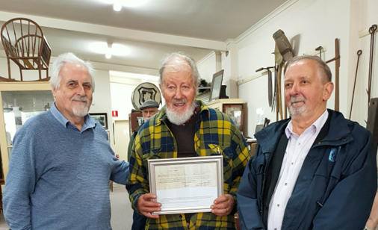
Figure 6 Photo courtesy of WV Preiss.
Questions remain. How did this Certificate presented in South Australia turn up in a London auction room in a job lot?
When and how did Daniel Schlinke move from being a baker to being a miller? Had he trained in both trades before moving to South Australia?

Bertha Teusler
His first wife, Bertha Mathilde Teusler, was born on 29 November 1822 and came to South Australia with her mother, Johanna Maria Teusler (nee Koehler) and her second husband, Johann Friedrich August Fiedler and four children from his first marriage. Her mother died on 5 December 1838, 17 days after arrival at Port Adelaide, leaving Bertha at 16 to look after her stepfather and 4 step-siblings aged 5½ to 16. In 1836, prior to leaving Prussia, her stepfather August Fiedler had appealed to the Prussian King for his wife’s children, Bertha and Karl Emil, in the care of their guardian, their grandfather, Teusler, a businessman, to be able to emigrate with them; only Bertha came to Australia - and then her mother died.
In South Australia, Bertha had 2 suitors, the missionary Clamor Schürmann and the miller Daniel Schlinke, 15 years her senior. The details are covered by Schürmann’s extensive diaries and the recently released Greg Lockwood book Diary of CW Schürmann. The diaries indicate the involvement of Pastor Kavel and the Church. It is possible that Bertha’s stepfather, August Fiedler, thought that the entrepreneur Schlinke was likely to be more able to assist his business interests than the missionary Schürmann. Bertha was under pressure from two courtiers (older men and she was only 17) and her stepfather. Daniel Schlinke may have been closer to Kavel than Schürmann (witness the later transfer of Tanunda property and Kavel's annoyance and frustration that the missionaries were not under his control).
My American 4th cousin, Stephen (Woody) LaBounty also quotes from an earlier translation of the Schürmann diaries. He reports that Bertha Teusler and Daniel Schlinke were married on 8 July 1840 by Pastor Kavel at Klemzig, South Australia, either in the church or at the Fiedler home. They had seven children before her death at age 30 on 10 December 1852.

The Bethany Mill
On 18 May 1842, Daniel Schlincke purchased a land grant of 135 acres of Sections 1936 and 1937 of the Wiltshire Special Survey at Bethany for ₤135. Note the spelling of his surname (with a “c” before the “k”).
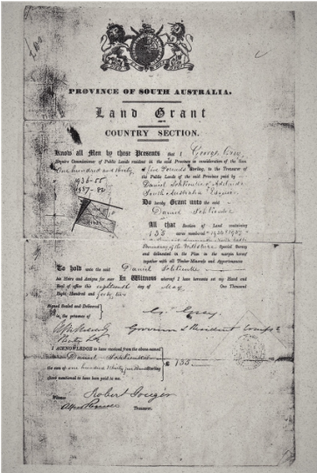
A report in the Sydney Morning Herald of 29 September 1843, taken from the Southern Australian of 18 August 1843 showed that Daniel Schlinke operated a bakery business from Grenfell Street, Adelaide, and reported the building of the mill at Bethany. It is unusual for South Australian activities to be reported in Sydney newspapers so the building of the mill must have been seen as very significant.
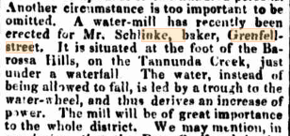
Daniel G Brock reported "Comparatively near to this village [Bethany], up one of the ravines, an enterprising German has erected a substantial stone mill, which is driven by water, conveyed in a trough three hundred feet to the water-wheel. The building reflects great credit on the builders, who have shown great skill in the erection. The mill is romantically situated up the gorge, and the water is seen breaking out in the different refts of the broken range."
A pen drawing of the mill shows what it would have looked like before it was damaged.
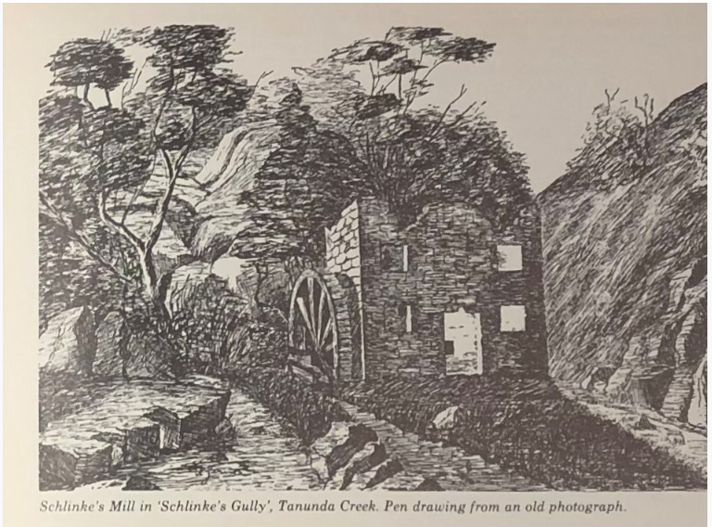
Grain and milling were very important in the early years of the colony of South Australia. Anna Schrapel reports that local farmers from all over the Valley brought wheat for Daniel Schlinke to grind. By 1844, 18 months after the arrival of the pioneers of Bethany, they had 495 acres under cultivation, of which 381 ½ acres were wheat. By 1847, the mill was grinding 200 lbs of flour.
Drays pulled by bullock teams carted the local wheat along the sloping banks of the creek up to the mill, causing huge ruts. Sometimes they did not make it. 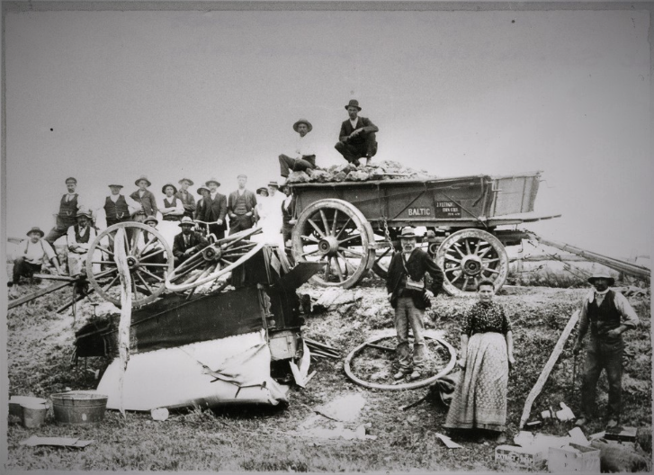
Figure 7 Broken down wagon on its way to the mill. B45896 State Library of South Australia.
An article notes that steam-powered flour mills were an early machine technology operating in Adelaide in response to the success of the 20 acres of wheat planted on the Adelaide plains in 1838. Flour milling became the first secondary industry of the colony.
Schrapel reports that between 1848 and 1850, water supply went from inadequate to destructive, and a flood destroyed the aqueduct. The first two storeyed water powered mill in South Australia, at Schlinke’s Gully, only survived 7 years.
A drawing of Daniel Schlinke’s Bethany mill, after being damaged, is shown below.
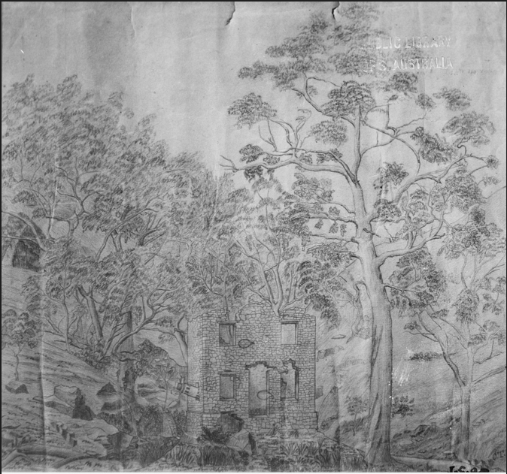
Figure 8 'Sketch by J.G.O. Tepper / (Mill supposed to be at Mr. Schlinke's mill, (baker) at Tanunda Creek and the second water mill in S.A.. Details supplied by Mr. T.P. Lippinus 21/9/1976). Watermill [B 4159]. State Library of South Australia.
However, the Schlinke’s Creek mill was destroyed by floods in the 1920s and little remains of this mill.
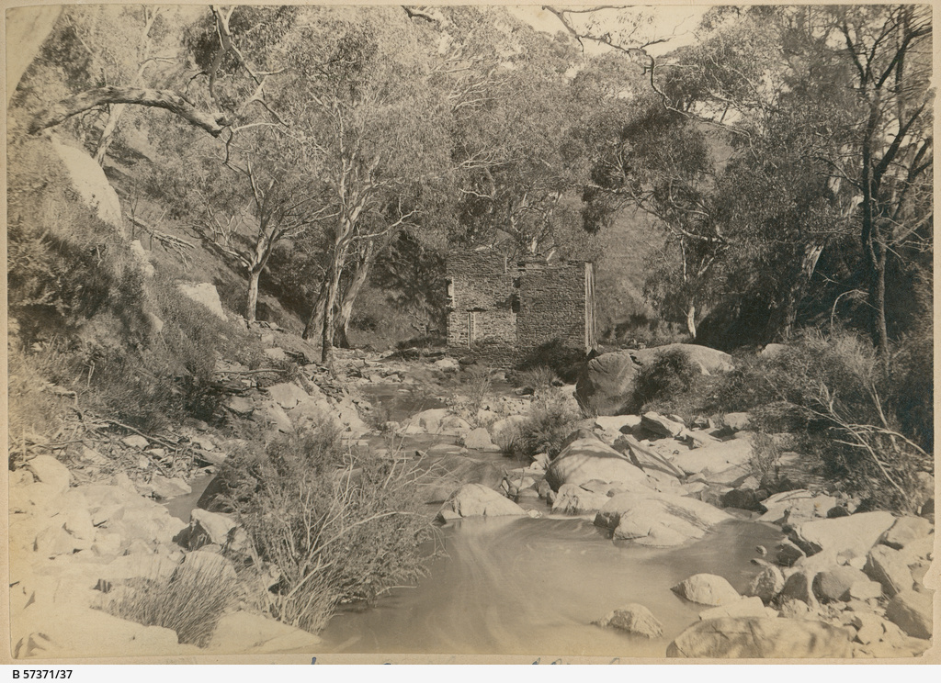
Figure 9 Ruins of Schlinke’s Gully mill (Image courtesy of SLSA B57371/37).
“A Historical Walk of Bethany” details that 3 cottages were built on the property. These included the first residences in South Australia of Daniel Schlinke’s sister, Rosina Bradtke (nee Kucke, nee Schlinke) and her husband, Wilhelm Bradtke, and their family, and her daughter, my great grandmother Louise and her husband, my great grandfather, Johann Christian Mann. The ruins of one of these cottages is shown below.
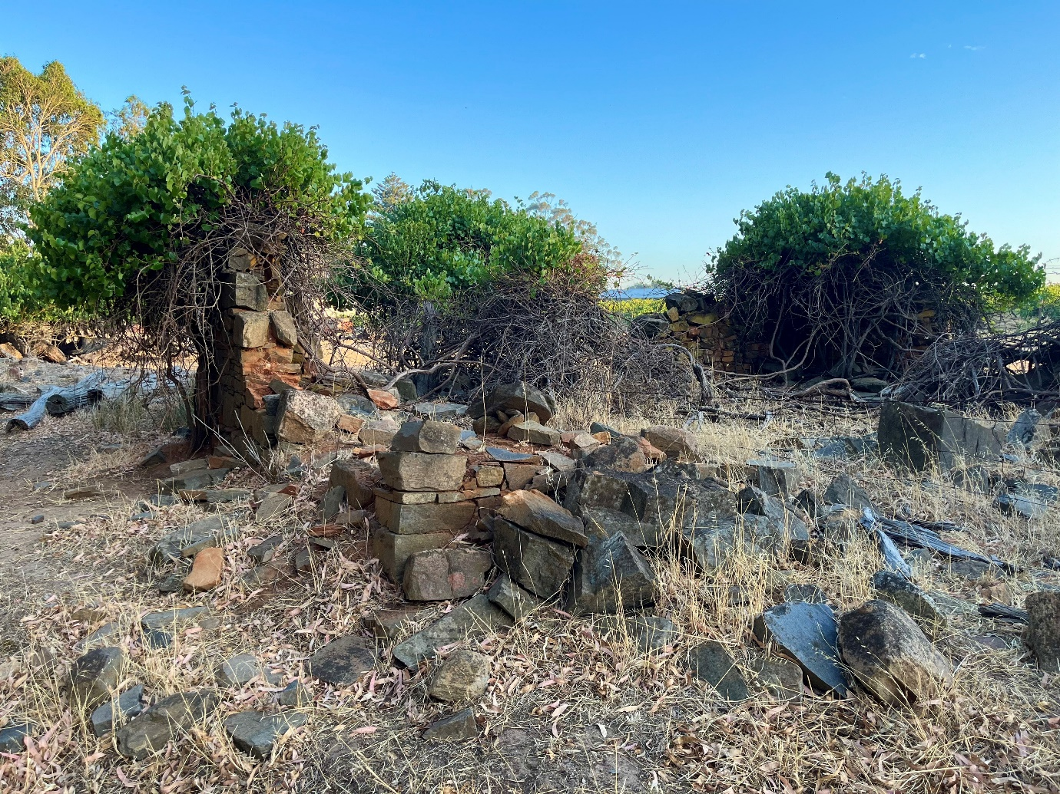
Figure 10 Ruins of a cottage. 2025. Picture by Anna Schrapel
This brochure also shows that the mill only functioned for a few years until it was damaged by flood. The property on which the mill was built was purchased from Daniel Schlinke in 1858 by the Schrapels. Before selling his original title to the Schrapels, Daniel Schlinke bought a further 55 acres towards the foothills of Bethany for £5 per acre. Today, Bethany Wines operates from the original site.

Tanunda Mill
A more reliable 6 horse-power steam flour mill was built by Ferdinand Wilhelm Bollensdorf in Tanunda by 1850/51 on land transferred to Daniel Schlinke from Pastor Kavel. It is believed to have commenced operating in 1848. Photos of the mill then and now are shown below.
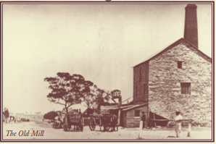
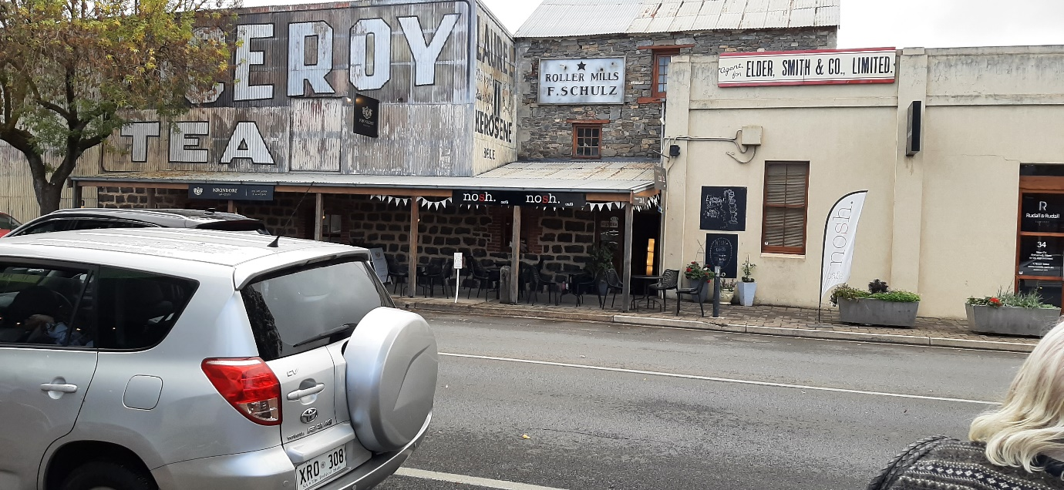
The location on the corner of Murray Street and Jane Place is shown below.
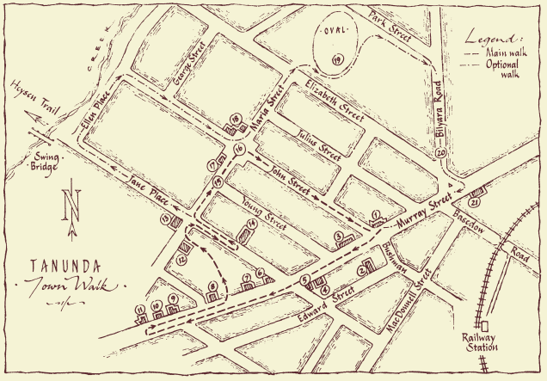
Daniel Schlinke may have ceased operating the mill from about 1863, given the advertisement in the South Australian Register to lease or sell the mill.
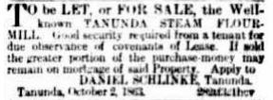

Tanunda life
Daniel Schlinke is listed in the “Church Book of the Lutheran, Apostolic Congregation of Langmeil, Upper-Langmeil, Light’s Pass, Bethany, and surroundings, 1849” as having 9 other members of the family living with him in Tanunda. I have examined the Langmeil Church registers and he is described as a mühlenbesitzner (mill owner) in 1850 and an eigenthümer (property owner) from 1852 onwards.
He was also trustee of the Church and overseer of the Langmeil Church cemetery.
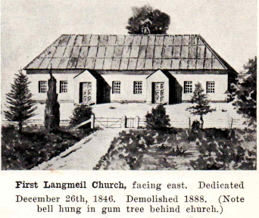
Figure 11 Source: Langmeil 1843 - 1968.
According to the 1990 Tanunda Heritage Survey, 30 Murray Street, Tanunda (now Valley Ford offices) was Tanunda's first hotel building and was probably built by Daniel Schlinke by 1865. Initially it was Daniel Schlinke’s Tanunda home.
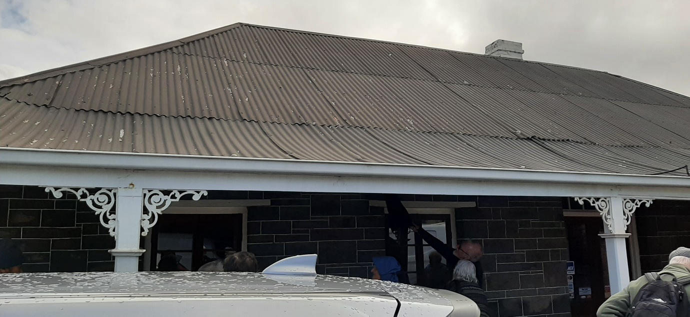

Ottilie Louise Maria Laura von Hoffmann
After his first wife, Bertha’s death, Daniel Schlinke married Ottilie Louise Maria Laura von Hoffmann on 9 March 1854 and they had three children. As reported by Stephen LaBounty, according to family stories, Daniel’s relationship with Ottilie became contentious, with fights over money and her spending. These family stories have been confirmed by classified ads Daniel took out in a number of South Australian newspapers warning the public that he would not honour debts his wife might incur.
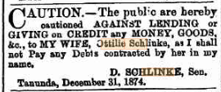
From her headstone, we know that Ottilie died on 2 July 1912 (aged 93) in San Francisco, California, and is buried in Cypress Lawn Memorial Park, Colma, San Mateo County, California. Her will left $10 to her son, Otto, address unknown, with the rest shared by her daughters, Louise Frisch of Port Pirie, South Australia (or her 4 children), and Marie Nugent of San Francisco, California.
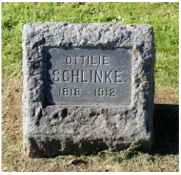
Colma is about 16 miles south of Sausalito, where two of her stepsons lived.
These two step-sons, Daniel Schlinke’s sons from his first marriage to Bertha Teusler, Johann Emil and Daniel Joseph, also caused some financial challenges and left Australia. Their exploits are briefly covered later in this paper and are eloquently and more adequately covered on http://woodylabounty.com/slinkey-story.php.
According to Anna Schrapel, Johann Daniel Schlinke, whilst residing in Tanunda, was a member of the Masonic Lodge in his later years.

His grave
Johann Daniel Schlinke died at Tanunda on 13 August 1878 and is buried beside his wife Bertha (nee Teusler) in the Langmeil Lutheran Cemetery at Tanunda.
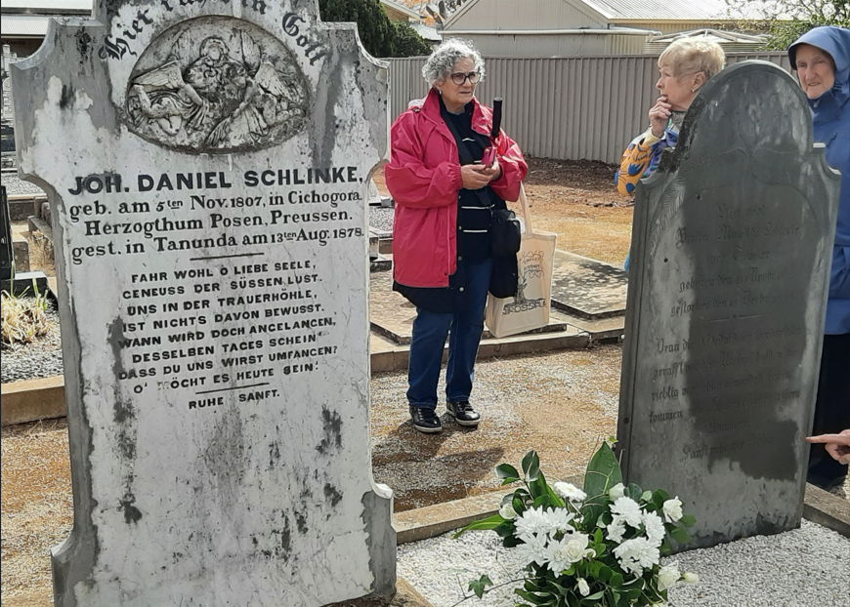

His estate
After Daniel Schlinke’s death, the Tanunda Mill was part of his estate and was auctioned.
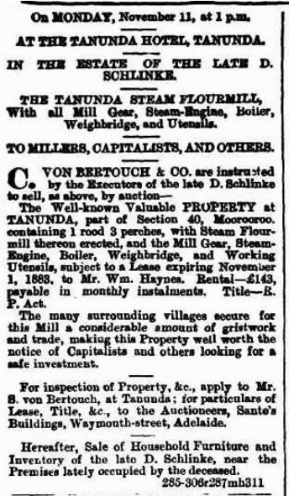
The mill sold for ₤802 to its tenant, Mr W Haynes.
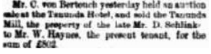
The following documents relate to the winding-up of his Estate.
The signatories are Sophus August Theodore von Bertouch and Carl August Schubert.
The accounts show his estate was £1,885-12-9.
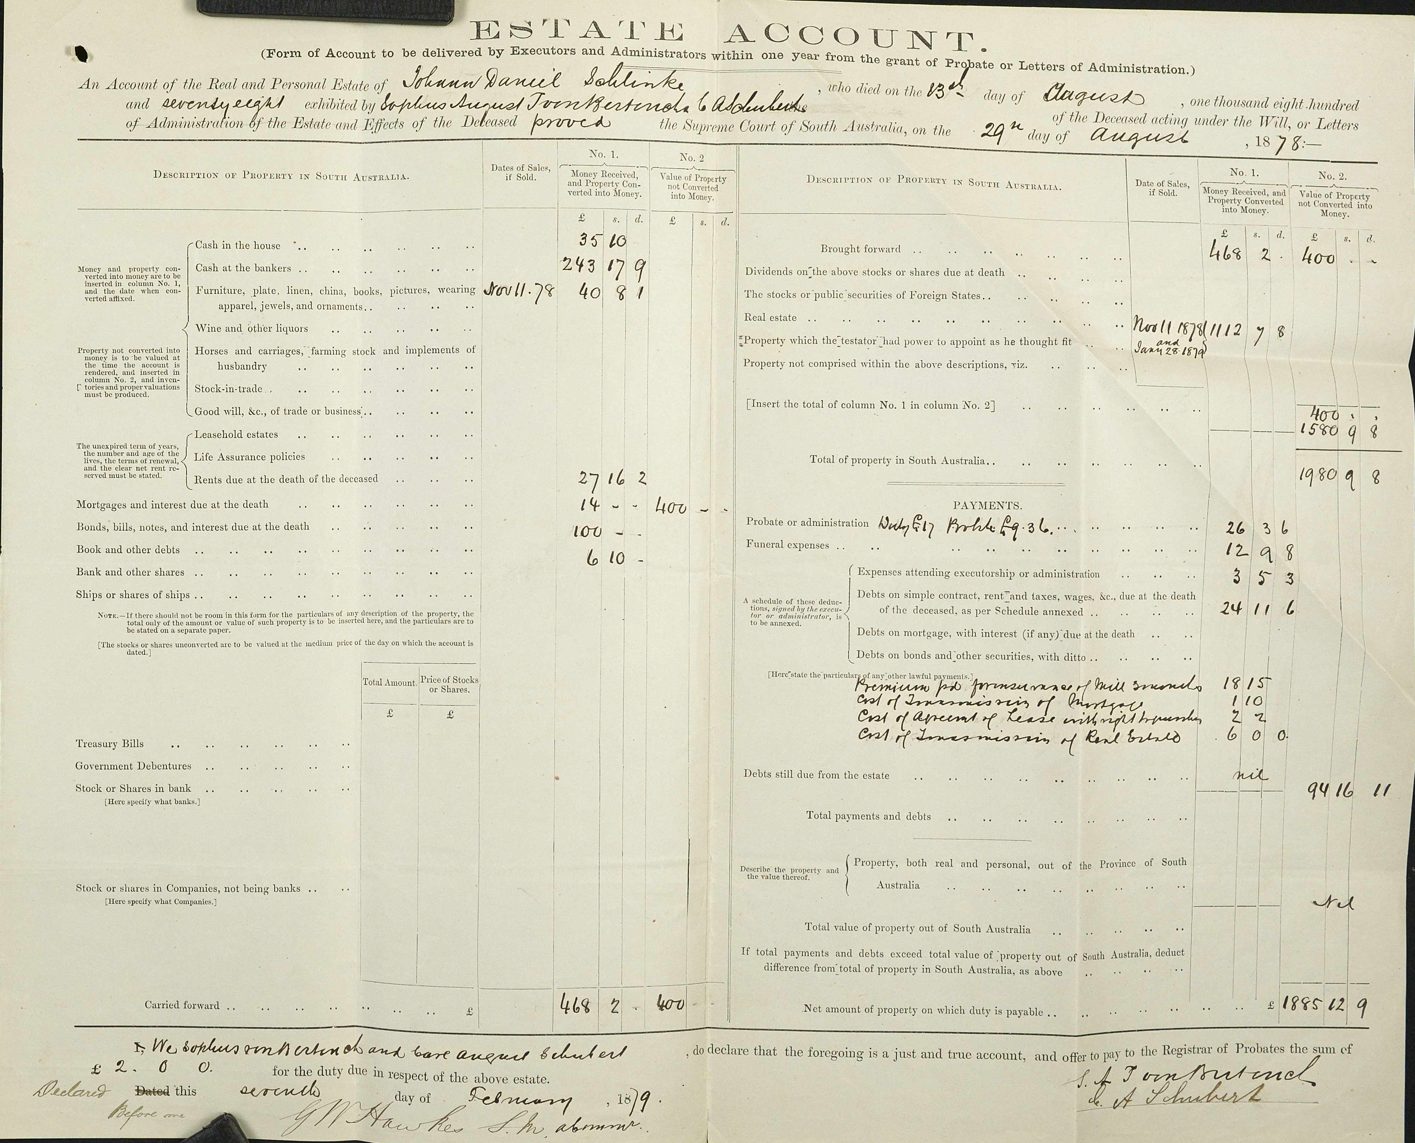
From my calculation, £1,885-12-9 in 1879 converts to over $600,000 in 2025.
The distribution of his estate to his wife and children is shown below. Note Johann Emil’s share.
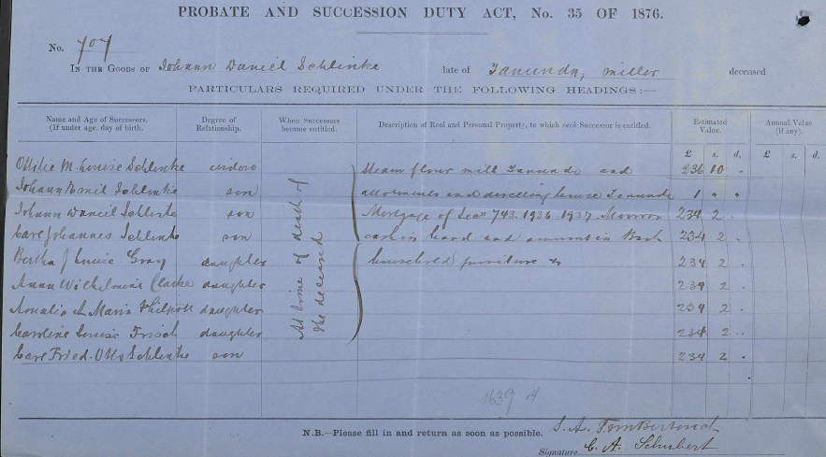 This is because Daniel Schlinke’s will contained the following specific bequest.
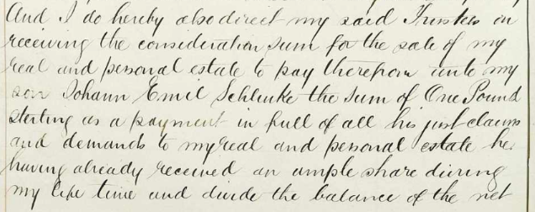

His emigrant sons
Johann Emil Schlinke was Daniel Schlinke’s second son by Bertha Teusler. He was born on 3 November 1842 in Adelaide. His mother died when he was 10 and his father remarried two years later. He attended St Peter’s College and played cricket and football (for the Adelaide Football Club) in the early 1860s, and was secretary of the St Peter’s Old Scholars’ Association and played pianoforte as part of a duet.
He was made insolvent in the week ending 16 March 1866. He is reported to have left Australia, under the name Saunders on the barque Anna bound for San Francisco, after embezzling from his employer, Francis Clark and Sons.
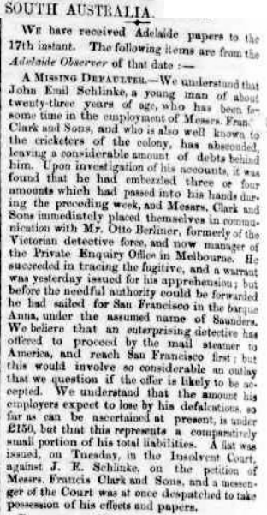
Debts are not all he left behind. On 15 September 1866, he was named as the father of Annie Sophia Salcombe Schlinke born in Adelaide to Kate Maria Salcombe.
On arrival in San Francisco, he was involved in a number of businesses, several of which burnt down. Their losses appear to have been almost completely covered by insurance. In 1873, John E Slinkey (anglicised and spelt s-l-i-n-k-e-y) was naturalised as a US citizen in California. In 1876, he purchased a large hotel in Sausalito overlooking the bay.
On 1 May 1882, he opened the El Monte Hotel.
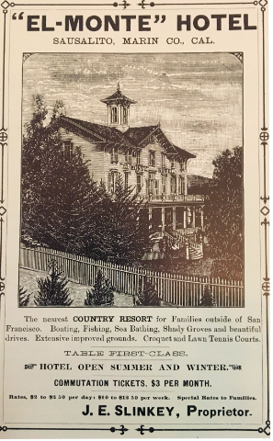
His story is incredible and indicates a full life and may be best left to another time or to Stephen LaBounty who gathered all the information. John E Slinkey died on 4 March 1920 in San Francisco.
His brother, Daniel Joseph Schlinke was born in August 1841 in Adelaide and was the oldest of Daniel and Bertha’s children. He also appeared in the courts in South Australia before turning up in California working in one of his brother’s establishments as a bartender. Like his brother, it was a colourful life in California, including as a poundkeeper, ended when he suicided on 16 August 1900 in Sausalito.

The land for the Institute
Back to their father. Johann Daniel Schlinke donated land at 28 Murray Street for Tanunda’s first Institute. I am informed the bluestone came from the quarry on the property he had first settled on.
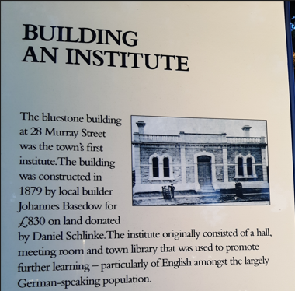

Acknowledgements
My sincere thanks to:
- Anna Schrapel, for discussion and her knowledge of the Bethany property and the Barossa;
- Stephen W LaBounty, for his details on Daniel Schlinke’s sons in the USA;
- Don Ross, for sharing his knowledge of the Barossa and knowing that the Barossa Museum was the right place for the Naturalization Certificate;
- Mark Cody, for contacting me about the Naturalization Certificate;
- Aileen and Victor Preiss, for ongoing advice, encouragement and assistance over the years;
- Lois Zweck, for her advice on the early German settlements in South Australia; and
- Ruth Ashley, for her knowledge and advice on mills in early South Australia,
without whose information and assistance, this would have been a much poorer presentation.

Philip Mann
26 June 2025.

Sources
A Dwelling-Place at Bethany, HFW Proeve, 1983.
Bethany Profiles, compiled by PA Scherer, 1993.
The history of the founding of the village of Cicha Góra, https://www.cichagora.pl/historia/
Schlinke-Teusler Family in South Australia, Stephen W LaBounty, Schlinke_Teusler-Report_2020_02_07, February 2020.
http://woodylabounty.com/slinkey-story.php.
https://www.sausalitohistoricalsociety.com.
19-Century Emigration of ‘Old Lutherans’ from Eastern Germany to Australia, Canada, and the United States, Smith, Clifford Neal, Baltimore: Genealogical Publishing Co., 2004.
Lutheran Almanac, 1919.
A Miller’s Tale: The Memoirs of John Dunn of Mount Barker, Edited by Anthony Stuart, 1991.
Schlinke’s Gully History, compiled by Anna Schrapel (COVID Project) April 2020.
The Barossa – A Vision Realised. The 19th Century Story, Don Ross.
From Shuttle to Plough: The Gallasch Family: Early Pioneers of South Australia, Third Edition, February 2003, compiled and printed by Eric and Ruth Fiebig.
The Barossa Survey: Final Report of A Research Project by the School of Architecture, S.A. Institute of Technology, and the Department of History, Adelaide College of Advanced Education, for the Australian Heritage Commission. Published 1977. https://data.environment.sa.gov.au/Content/heritage-surveys/3-Barossa-Survey-Vol-3-1977.pdf.
The Barossa Council Heritage Review Volume I 2001, prepared for The Barossa Council and Department for Environment, Heritage and Aboriginal Affairs by McDougall & Vines. https://data.environment.sa.gov.au/Content/heritage-surveys/2-Barossa-Council-Heritage-Review-Vol-1-2001.pdf.
Australia, South Australia, Will and Probate Records, database, FamilySearch.
Langmeil Congregation 1843 – 1968, printed by the Lutheran Press.
http://hauland.de/einfuehrung/
https://fotopolska.eu/
https://www.archivaria.com.
www.saghs.org.au.
www.meyersgaz.org.
http://www.theshipslist.com.
https://en.wikipedia.org.
https://trove.nla.gov.au.
http://adb.anu.edu.au/biography/angas-george-fife-1707.
https://guides.slsa.sa.gov.au.
https://www.ancestry.com.
https://www. familysearch.org.
https://billiongraves.com/.
https://www.findagrave.com.
https://www.walkingsa.org.au.
https://www.barossa.com.
http://www.collections.slsa.sa.gov.au.
https://adelaideaz.com.
https://www.maps.google.com

According to the Langmeil (Tanunda) church register, as reported on Page 1 of Bethany Profiles, compiled by PA Scherer, 1993.
https://www.cichagora.pl/historia/, accessed 13 May 2025.
https://en.wikipedia.org/wiki/Germanisation_of_the_Province_of_Posen, accessed 3 February 2024.
"Deutschland, Preußen, Posen, Katholische und Lutherisch Kirchenbücher, 1430-1998", FamilySearch (https://www.familysearch.org/ark:/61903/1:1:6FCT-GMHJ : Wed Dec 18 18:22:13 UTC 2024), Entry for Johann Daniel Schlinkes and Gottfried Schlinkes, 6 Nov 1807.
http://www.theshipslist.com/ships/australia/catharina1839.shtml.
Much of this section is from https://guides.slsa.sa.gov.au/c.php?g=410270&p=2794886, accessed 20 February 2024.
Much of this section is from https://en.wikipedia.org/wiki/August_Kavel, accessed 20 February 2024.
The Old Lutherans. https://www.archivaria.com.
http://www.theshipslist.com/ships/australia/catharina1839.shtml.
https://en.wikipedia.org/wiki/Confectionery, accessed 7 December 2023.
Lois Zweck, pers. comm., 9 December 2023.
http://adb.anu.edu.au/biography/angas-george-fife-1707.
Much of this section is sourced from Bethany Profiles, compiled by PA Scherer, 1993.
The German Naturalization Bill, Southern Australian, Friday 20 August 1841, page 2, https://trove.nla.gov.au/newspaper/rendition/nla.news-article71615175.3.pdf?followup=98db94cad1422d665923e23a80b1c179, accessed 26 May 2025.
Lutheran Almanac, 1919.
https://collections.slsa.sa.gov.au/resource/B+7801, accessed 7 December 2023.
A Miller’s Tale: The Memoirs of John Dunn of Mount Barker, Edited by Anthony Stuart, 1991, page 70.
South Australian Register, Saturday 11 March 1848, page 3, https://trove.nla.gov.au/newspaper/rendition/nla.news-article48727364.3.pdf?followup=80e642c93af987e667aa8bf13e465ced, accessed 26 May 2025.
Law and Police Courts. In the Supreme Court. Adelaide Observer, Saturday 13 May 1848, page 2, https://trove.nla.gov.au/newspaper/rendition/nla.news-article158926071.3.pdf?followup=0f3937f201b561583dca75e12e599ddf, accessed 26 May 2025.
From Latin, meaning "in the clouds". In law, In abeyance.
Scherer.
Smith, Clifford Neal, 19-Century Emigration of ‘Old Lutherans’ from Eastern Germany to Australia, Canada, and the United States, Baltimore: Genealogical Publishing Co., 2004.
Stephen W LaBounty, Schlinke-Teusler Family in South Australia, Schlinke_Teusler-Report_2020_02_07, February 2020.
Land in the vicinity of the adjoining villages of Tanunda and Langmeil was originally laid out as portion of the 'Twenty-Seventh Special Survey', claimed by Edward Rowlands and Joseph Gilbert on 17 July 1839. A resurvey was carried out by James Poole in 1842 and called the 'Wiltshire Special Survey'.
Schlinke’s Gully History, compiled by Anna Schrapel (COVID Project) April 2020.
Source: Anna Schrapel.
https://trove.nla.gov.au/newspaper/rendition/nla.news-article12427103.3.pdf?followup=5a1b21039f107b70adf7292c0be19ad0, accessed 9 December 2023.
Southern Australian (Adelaide, SA : 1838 - 1844), Friday 18 August 1843, page 2, https://trove.nla.gov.au/newspaper/rendition/nla.news-article71617716.3.pdf?followup=e4524db68e60c245bb86ab51230be0f6, accessed 6 May 2025.
South Australian Register, 18 October 1843: 2. http://nla.gov.au/nla.news-article27445758.
Proeve, page 25.
Schlinke’s Gully History, compiled by Anna Schrapel (COVID Project) April 2020.
The Barossa – A Vision Realised. The 19th Century Story, Don Ross, page 49, from Allen’s Almanac 1844.
Schrapel.
https://adelaideaz.com/articles/god-early-wheat-crops-bring-a-boom-in-flour-mills-machinery-to-the-fledgling-colony, accessed 4 January 2024.
HFW Proeve, A Dwelling-Place at Bethany, 1983, page 25.
The Barossa Council Heritage Review Volume I 2001, prepared for The Barossa Council and Department for Environment, Heritage and Aboriginal Affairs by McDougall & Vines. https://data.environment.sa.gov.au/Content/heritage-surveys/2-Barossa-Council-Heritage-Review-Vol-1-2001.pdf, accessed 2 October 2023.
“A Historical Walk of Bethany”, https://www.walkingsa.org.au/wp-content/uploads/2016/09/Bethany20Town20Walk.pdf, accessed 6 December 2023.
Schrapel.
“A Town Walk of Tanunda”, https://www.barossa.com/file/zkz7ppvh9/Tanunda%20Heritage%20Town%20Walk.pdf, accessed 6 December 2023. Don Ross advised 3/4/2025 of a letter written in Tanunda in 1848 by Daniel Thiermann who states that the mill was operating then.
South Australian Register (Adelaide, SA : 1839 - 1900), Friday 27 November 1863, page 1, https://trove.nla.gov.au/newspaper/rendition/nla.news-article50160798.3.pdf?followup=690d7c03d94c5d690ce60d50681a7c46, accessed 15 February 2024.
Langmeil Congregation 1843 – 1968, printed by the Lutheran Press.
In a visit to the Lutheran Archives 30 January 2024.
https://data.environment.sa.gov.au/content/heritage-surveys/lower-north-eight-towns-heritage-survey-tanunda-1990.pdf, accessed 31 December 2023.
Stephen W LaBounty, Schlinke-Teusler Family in South Australia, Schlinke_Teusler-Report_2020_02_07, February 2020.
https://www.findagrave.com/memorial/202133453/ottilie-schlinke, accessed 6 February 2024.
California, U.S., Wills and Probate Records, 1850-1953, accessed via Ancestry.com, 15 February 2024.
Google Maps, accessed 6 February 2024.
The photo below is from BillionGraves.
1878 https://trove.nla.gov.au/newspaper/article/160114377, accessed 6 December 2023.
South Australian Register (Adelaide, SA : 1839 - 1900), Monday 18 November 1878, page 1, https://trove.nla.gov.au/newspaper/article/42990125, accessed 6 December 2023.
FamilySearch, Probate and Administration Books, numerical series - Probate Registry: South Australia. Probate Records 1877–1878, https://familysearch.org/ark:/61903/3:1:3Q9M-CSN1-G9FF, accessed 22May 2025.
"Australia, South Australia, Will and Probate Records," database, FamilySearch (https://familysearch.org/ark:/61903/3:1:3Q9M-CSN1-G5K?cc=3007557 : 26 September 2019), > image 1 of 1; Filae, Genalogie.com, Paris. https://www.familysearch.org/ark:/61903/3:1:3Q9M-CSN1-G5K?cc=3007557&personaUrl=%2Fark%3A%2F61903%2F1%3A1%3AQY3Y-59MM, accessed 9 December 2023.
Commercial Intelligence, South Australian Register, Friday 16 March 1866, page 2, http://nla.gov.au/nla.news-article41032816, accessed 7 October 2023.
Births Registration, Annie Sophia Salcombe Schlinke, Genealogy SA, accessed 6 February 2024.
Colonel Slinkey and the El Monte Hotel, 5 October, 2016, Jack Tracy, Sausalito Historical Society, https://www.sausalitohistoricalsociety.com/2016-columns/2016/10/5/colonel-slinkey-and-the-el-monte-hotel, accessed 18 February 2024.

