1845 Retrospective

Major change for my great grandmother Johanne Louise Bradtke

Prepared by Philip Mann for the Wednesday 3 December 2025 Lunch Meeting of The Pioneers Association of South Australia Inc.
I will cover 1845 from the perspective of my great grandmother, Johanne Louise (“Louise”) Bradtke.
She was the eldest child of the 5 Bradtke children who arrived in South Australia on the Heerjeebhoy Rustomjee Patel in 1845.
Louise was born in Cicha Gora, Posen, Prussia, to Anna Rosina Dorothea Schlinke (later Bradtke) on 7 June 1823 but details of her father are unknown at this stage. Her mother married the blacksmith, Wilhelm Bradtke, in 1829.
Cicha Góra is a village 5kms from Neutomischel (Nowy Tomyśl in Polish) in Posen. Its location is shown in the extract from Google Maps.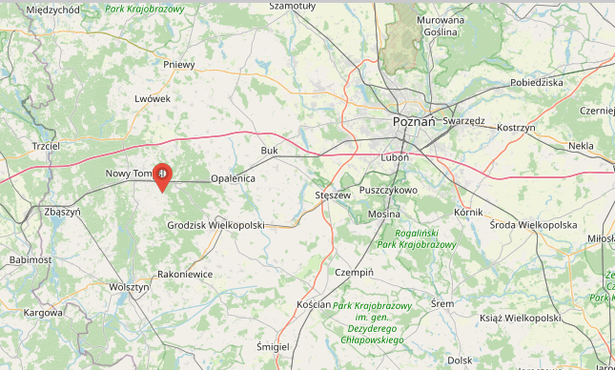
The history of Cicha Góra, which follows, has been extracted from the history page on the village’s website.
It was established on 11 November 1757 as a location for an Olęder (German Haulander) settlement created by clearing the forest and improving the land.
The Polish landowners who settled German colonists wished to increase the area of ​​cultivation and the profitability of their estates by collecting rents from the settlers.
Taking advantage of the specific soil and climate conditions, they cultivated hops and wicker, among other things. In addition, they were engaged in animal breeding, beekeeping, fishing, crafts, trade and ran inns, which may have been what Daniel Schlinke’s father did.
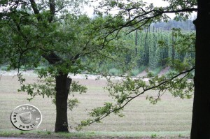
Figure 1 View over the hop fields of Cicha Góra, http://hauland.de/aus-der-kirchenchronik-von-hammer-boruy-einweihung-der-kirche-1777-und-einpfarrung-der-gemeinde-chicagora-1817/, accessed 8 June 2025.
Louise grew up in a rural community, maybe in a cottage like this 300 year old cottage (photo from the Bradtke book, page 18).
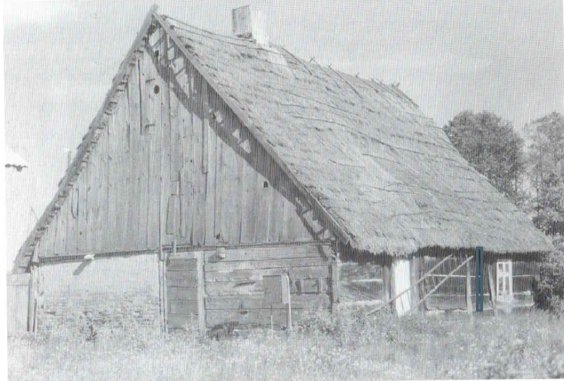
As the oldest girl in a growing family, Louise would have been a major assistant to her mother in caring for and bringing up the younger ones.
I have no information on why the family left Cicha Gora. Her uncle, Daniel Schlinke, had come to South Australia with the Old Lutherans and had established a water mill at the new village of Bethany in the Barossa and could well have written of the opportunities in this distant land. The King of Prussia, who had been persecuting the Old Lutherans, had died in 1840 and religious restrictions were easing. But Posen was part of Prussia and, even in the Haulands, the lives of rural peasants would have been very restricted, for example, with ownership of land and who they could marry.
It would be reasonable to assume that, at the beginning of 1845, the decision had been made, and the Bradtke family would have been disposing of assets they could not take with them and packing up what could come with them. Louise would have been deeply involved in helping her pregnant mother care for and organise the children.
And first, they had to get to the port of Bremen. Today that distance is 584 kilometres (according to Google Maps). There were no trains from Posen to Bremen in 1845. In 1845, it would have been a multi-stage journey, likely involving horse-drawn coach or wagon for the initial land travel, followed by a boat or steamboat along rivers and canals. The specific route would have depended on available transportation, cost, and the destination of the traveller. Most of the passengers on this ship were from Posen, Silesia or Brandenburg and their travel arrangements would have been organised by agents; Alfred Swaine, who was connected with the South Australia Company, came with them on the Patel in a cabin and is likely to have organised all the European and ocean travel.
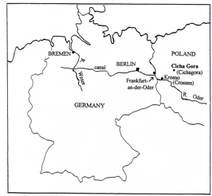
Figure 2 Cichagora to Bremen. Bradtke Family History, page 12.
Departure: April 21, 1845, from Bremen, Germany
Arrival: September 18, 1845, at Port Adelaide, South Australia
Vessel Details: 510-ton, 3-masted ship
Captain: Eugene Laun
Surgeon Superintendent: L. Callmann
Passengers: 262 German immigrants
Journey Statistics: 7 births and 11 deaths occurred during the voyage
The Bradtke family (parents with girls 22 and 10, boys 16 and 5 and a baby boy born on board) travelled in steerage. According to Don Charlwood, emigrants travelling in steerage at that time:
… shared dormitory-type accommodation, based on government experience in transporting convicts.
…
‘Each berth was six feet square, and into each berth four people were fitted’ that is eighteen inches of width for each person. The allowance for convicts had been precisely the same, for slaves, sixteen inches.
…
… headroom of only six feet four inches was claustrophobic, though on many ships it was more than this by a foot, even by two feet. Heavy beams cut into this headroom. Within this vertical space fitted the two levels of bunks, the lower one with a space of six inches beneath it for passengers’ heavier belongings. (Their bulkier possessions were stowed in the hold.)
… on most ships, a couple had not only another couple above or below them, but a second couple within arm’s reach to one side. Within a six-foot square, four people slept; four more lay directly below them. Engravings show that on some ships curtains suspended from rings could be drawn across the open ends or the sides of bunks, but they were not fitted on all ships, and were also too stifling to use in the tropics.
Louise would have slept in the single women’s quarters, and the oldest boy would have slept in the single men’s quarters at the other end of the ship.
After almost 5 months at sea with no recorded stops, they reached Port Adelaide which had been settled for less than 9 years. The watercolour by an unknown artist provides a picture of what awaited them.
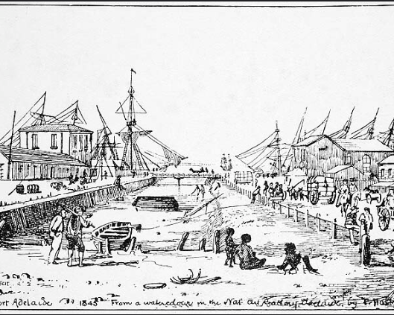
Figure 3 Artist Unknown , Australia (20th Century), Port Adelaide, 1845, from A Watercolour in the National Art Gallery, Adelaide, Pen and ink sketch.
According to the Bradtke Family History, the family was probably met by Johanne Louise’s uncle, Daniel Schlinke, and taken by wagon and foot to his home in Bethany, where he was operating a water mill.
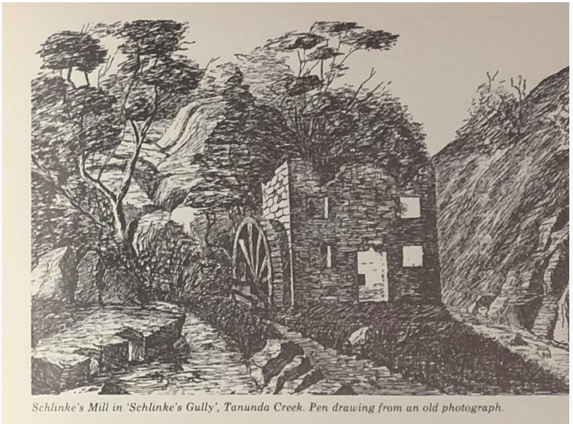
1845 was thus a year that began in a village in Prussia, involved a family moving with a large group of people to a place where they would have seen the sea for the first time and then travelling in cramped conditions on a ship to an unknown place and finishing in an undeveloped rural village.
Philip R Mann,
3 December 2025.

Sources
Bradtke Family History, 2000.
https://www.cichagora.pl/historia/, accessed 13 May 2025.
Poznan Project, http://poznan-project.psnc.pl/index.php?lang=en#prettyPhoto.
https://www.flickr.com/photos/paelocalhistory/13753634913, accessed 2 August 2025.
H.F.W. Proeve, A Dwelling-Place at Bethany: The Story of a Village Church.
http://hauland.de/aus-der-kirchenchronik-von-hammer-boruy-einweihung-der-kirche-1777-und-einpfarrung-der-gemeinde-chicagora-1817/.
https://www.theodorebruceauctions.com.au/auction-lot/artist-unknown-australia-20th-century-port-a_33E45508A9, accessed 11 November 2025.
Don Charlwood, The Long Farewell: A history of the first migrations to Australia, 2018.

Father’s name was left blank on her birth record.
https://www.cichagora.pl/historia/, accessed 13 May 2025.
His obituary shows he was born in Weimar, Germany, on 28 February 1819 and died in Norwood, SA, on 2 May 1919. Register (Adelaide, SA : 1901 - 1929), Monday 3 May 1909, page 4, https://trove.nla.gov.au/newspaper/article/57865457
Don Charlwood, The Long Farewell: A history of the first migrations to Australia, 2018.
https://www.theodorebruceauctions.com.au/auction-lot/artist-unknown-australia-20th-century-port-a_33E45508A9, accessed 11 June 2025.

